SFC MODELS FOR MACROECONOMIC ASSESSMENT OF THE TRANSITION TOWARDS A CIRCULAR ECONOMY

# D5.1 – SFC Models for Macroeconomic Assessment of the Transition towards a Circular Economy

|  |
| --- |
| **Grant Agreement nº:** 101003491 |
| **Project acronym:** JUST2CE |
| **Project title:** A JUST TRANSITION TO THE CIRCULAR ECONOMY |
| **Topic:** Understanding the transition to a circular economy and its implications on the environment, economy and society |
| **Project Duration:** 2021/09/01 – 2024/08/31 |
| **Coordinator:** Universitat Autònoma de Barcelona (UAB) |
| **Associated Beneficiaries:**   1. UNIVERSITAT AUTÒNOMA DE BARCELONA 2. UNIVERSIDAD DE VIGO 3. THE UNIVERSITY OF SHEFFIELD 4. UNIVERSITA DEGLI STUDI DI NAPOLI PARTHENOPE 5. CENTRO DE ESTUDOS SOCIAIS 6. UNIVERSITY OF LEEDS 7. UNIVERSITY OF CAPE TOWN 8. KENTRO EREVNON NOTIOANATOLIKIS EVROPIS ASTIKI MI KERDOSKOPIKI ETAIREIA 9. AGENCIA DE RESIDUS DE CATALUNYA 10. MEKELLE UNIVERSITY 11. KUMASI HIVE 12. SCIENTIFIC AND INDUSTRIAL RESEARCH AND DEVELOPMENT CENTRE 13. AFRICAN CIRCULAR ECONOMY NETWORK 14. ENERGY@WORK SOCIETA' COOPERATIVA A R.L. |

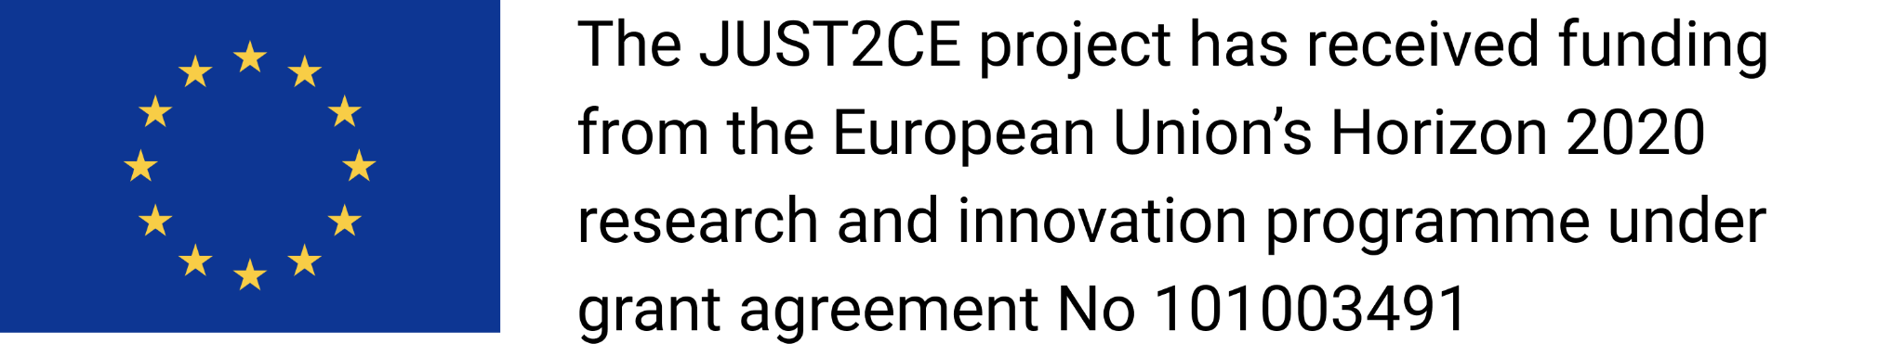

## PROJECT No. 101003491

Just2ce will assess the current state of transition towards the circular economy in relevant economic sectors and analyse possible transition scenarios, as well as their outcomes and impacts. It will identify the key factors that can stimulate or hinder this transition. Natural resources are extracted and transformed into products, which are eventually discarded. As many natural resources are finite, it is important to keep materials in circulation for as long as possible. This makes the transition to circular economy more vital than ever but is a responsible, inclusive, and socially just transition to a circular economy possible or even desirable? What technical, political, and social factors can enable or hamper such transformation? The EU-funded JUST2CE project will answer these questions. It will explore the economic, societal, gender and policy implications of the circular economy paradigm. The project’s findings will shed light on how to ensure democratic and participatory mechanisms when designing and managing such technology.

#### 

#### History Chart

|  |  |  |
| --- | --- | --- |
| **Version** | **Date** | **Implemented by** |
| **V2.0** |  |  |
| **V1.1** |  |  |
| **V1.0** | 11/08/2023 | Marco Veronese Passarella |

#### Disclaimer

*No part of this document may be reproduced and/or published by print, photoprint, microfilm or any other means without the previous written consent of the JUST2CE consortium. The content of this deliverable does not reflect the official opinion of the European Union. Responsibility for the information and views expressed herein lies entirely with the author(s).*

##### Version: 1.0

# Executive Summary

In the face of the looming climate crisis, the Circular Economy (CE) paradigm has gained significant traction among academic, policy-making, and industrial circles over the past decade. However, few studies address the economic viability of a transition to a circular economy, let alone the fairness of its social outcomes in the form of social and regional inequalities in terms of class, gender, and race. While there is an intuitive association between transitioning to a CE and achieving a more sustainable society, there has been limited scrutiny regarding the economic viability of this process. In order to address this, specific macroeconomic tools are needed to assess the joint impacts of CE interventions on society, the economy, and the ecosystem. The broad field of ecological macroeconomics can meet this need through various promising modelling approaches. This deliverable has two main objectives. Firstly, it provides a brief overview of developments in macroeconomic modelling addressing CE topics, with a focus on the most widely used approaches and tools. Secondly, the deliverable argues that combining input-output (IO) analysis with stock-flow consistent (SFC) modelling is one of the most promising methods for simulating, assessing, and comparing CE strategies and their social outcomes due to its formal treatment of system dynamics, institutional structure, and income distribution. To support this argument, the main features of a simplified IO-SFC model for a competitive economy are presented and discussed. In this model, money is endogenously created, production is demand-driven, and the macro-economy is divided into industries that produce goods and services while generating waste and CO2 emissions and depleting natural resources. Our preliminary experiments suggest that restructuring production and consumption patterns to adopt CE-driven practices may be insufficient to ensure a socially just transition to a more sustainable economy as long as production decisions remain driven by private interests.

# Table of Contents

D5.1 – SFC Models for Macroeconomic Assessment of the Transition towards a Circular Economy 2

PROJECT No. 101003491 3

Executive Summary 4

Table of Contents 5

List of abbreviations 6

[1] Introduction 8

[2] Overview of the Literature 8

[3] IO Models for CE Analysis: the State of the Art 10

[3.1] Type I Input-Output Models 11

[3.2] Type II Input-Output Models 12

[3.3] Type III Input-Output Models 13

[4] SFC Models for CE Analysis: Bridging the Gap 14

[5] A Benchmark IO-SFC Model: Main Features 15

[5.1] Economic and Financial Block 16

[5.2] Social Block 17

[5.3] Ecological Block 17

[5.3] Model Setting and Baseline Scenario 18

[6] CE Innovations in IO-SFC models: Preliminary Findings 19

[6.1] Single-Area Model 20

[6.2] Two-Area Model with Fixed Exchange Rate 20

[6.3] Two-Area Model with (Semi) Floating Exchange Rate 21

[7] Final Remarks 21

References 21

Appendix: Model Equations 27

[A.1] Households 27

[A.2] Production Firms (Current) 28

[A.3] Production Firms (Capital) 30

[A.4] Commercial Banks 31

[A.5] Government and Central Bank 31

[A.6] Population and the Labour Market 33

[A.7] Portfolio Choices 34

[A.8] Price Setting and Production Function 35

[A.9] The Balance of Payments 36

[A.10] Exchange Rate Regimes 37

[A.10.1] Fixed exchange rate 37

[A.10.2] Quasi-floating exchange rate 37

[A.11] Waste, Emissions 38

[A.12] Matter Extraction and Energy Use 39

[A.13] Circular Economy Innovations 40

Tables and Figures 43

# List of abbreviations

|  |  |
| --- | --- |
| **BSM** | *Balance-Sheet Matrix* |
| **CE** | *Circular Economy* |
| **CGE** | *Computational General Equilibrium* |
| **DSGE** | *Dynamic Stochastic General Equilibrium* |
| **EEIO** | *Environmentally-Extended Input-Output* |
| **IAM** | *Integrated Assessment Model* |
| **IO** | *Input-Output* |
| **IOM** | *Input-Output Matrix* |
| **MEIO** | *Macro-Econometric Input-Output* |
| **MRIO** | *Multi-Region Input-Output* |
| **PFM** | *Physical Flow Matrix* |
| **PSM** | *Physical Stock-Flow Matrix* |
| **SFC** | *Stock-Flow Consistent* |
| **TFM** | *Transactions-Flow Matrix* |
| **WIO** | *Waste Input-Output* |

# 

[1] Introduction

In the pressing context of the looming climate crisis, the concept of Circular Economy (CE) has gained significant traction among academic, policy-making, and industrial circles over the past decade. However, few studies address the economic viability of a transition to a circular economy, let alone the fairness of its social outcomes in the form of social and regional inequalities in terms of class, gender, and race. While transitioning towards a CE is intuitively associated with a more sustainable society, there has been limited examination of the economic viability of this process. To address this gap, there is a need for macroeconomic tools that can assess the joint impacts of CE policies on society, the economy, and the ecosystem. The field of ecological macroeconomics can fulfil this requirement through various promising modelling approaches.

This deliverable aims to achieve two objectives. Firstly, it provides a brief overview of the literature on advances in macroeconomic modelling in addressing CE issues, with a focus on the most widely used approaches and tools, among which system dynamics, industrial ecology, environmentally-extended input-output modelling, computational general equilibrium, material flow analysis, carbon footprint analysis, life cycle assessment, stock-flow consistent models, global value chains... The core of the literature consists of environmentally-extended input-output modelling, with multi-regional features that also may mix material and monetary analysis and include the treatment of waste.

Secondly, the deliverable argues that combining input-output (IO) analysis with stock-flow consistent (SFC) modelling represents one of the most promising methods to simulate, evaluate, and compare CE strategies and their social outcomes due to its formal treatment of system dynamics, institutional structure, and income distribution. While environmentally-extended input-output modelling offers a comprehensive view of the industrial and ecological interdependencies driving the structure of a competitive economy, the static nature limits its scope in analysing the dynamic and complex transition to a circular economy. In this context, macroeconomic models such as computational general equilibrium and stock-flow consistent analysis can capture the economic dynamics of such a transition. However, it is only SFC models, an economic approach to system dynamics, that can address the consistency of the economic system in terms of stocks and dynamics, which are of utmost relevance in an ecological context. In order to support this argument, the main features of a simplified ecological 2-area IO-SFC model for the world economy are presented and discussed. In this multi-sector post-Keynesian model, money is endogenously created, production is driven by demand, and the macro-economy is divided into industries that produce goods and services while generating waste and CO2 emissions and depleting natural resources.

Our preliminary experiments seem to suggest that restructuring production and consumption patterns to adopt CE-driven practices alone is insufficient to ensure the transition towards a more sustainable economy, as long as production decisions remain driven solely by private interests.

The deliverable is structured as follows. Section 2 provides an overview of the research methodology and the literature on the macroeconomic modelling of the transition to a circular economy. Section 3 contributes an in-depth review of the most relevant models: type I static input-output models with exogenous demand in many forms (environmentally-extended, waste, multi-regional, hybrid…), type II macroeconometric input-output models with endogenous demand, and type III supply-driven CGE input-output models. Section 4 presents the stock-flow consistent family of macroeconomic models and section 5 introduces a simplified SFC model that characterizes the transition to a circular economy and its social outcomes. Section 6 concludes with some final remarks.

[2] Overview of the Literature

While there is no single commonly accepted definition of the term “circular economy", different definitions share the basic concept of decoupling between natural resource extraction and use from economic activity, with increased resource efficiency and reduced resource demand as critical outcomes (Bocken et al., 2016; McCarthy, Dellink and Bibas, 2018). A fundamental view of the circular economy juxtaposes it in contrast to the conventional linear economic system, that is, one that focuses on closing resource loops. A broader view emphasizes the relevance of slower material flows, while the broadest conception involves a more efficient use of natural resources, materials, and goods within an existing linear system. The transition to the circular economy may be a significant driver of re-industrialisation, job creation, and economic growth: new economic opportunities may arise in many industries that lessen the environmental impact of economic activity, such as secondary material production, repair and remanufacturing, the service sector, and the sharing economy.

Although the CE has garnered significant attention in scientific literature, a comprehensive systematic review of key contributions on CE practices and strategies, along with their macro-level or societal impact beyond aggregate employment, has not yet been published (McCarthy, Dellink and Bibas 2018). Notably, Bimpizas-Pinis et al. (2022) stands out as an important exception, as the authors conducted a systematic analysis following the methodology displayed in figure 1 utilizing the SCOPUS database. 14 critical features of the circular economy in combination with 8 relevant macroeconomic models produced the 192 keywords for the search on SCOPUS (table 1), which identified nearly 50,000 unique articles. The large number of results was narrowed down to 405 articles by specifically selecting the articles that explicitly featured either the concept or the model as author keyword or in the abstract instead of the full text as a whole.

While CGE models focus on ‘resource efficiency’ the most, they least approach it from the perspective of the CE concept (figure 2). Instead, it is input-output (IO) models that emphasize CE the most, followed by non-CGE macroeconomic modelling and system dynamics. While ‘resource efficiency’ is not of central interest for SFC modelers, emphasis on CE is twice as much as for CGE models and the largest for ‘ecological’ concepts. Interestingly enough, the emphasis of system dynamics is roughly equally distributed among all concepts, which highlights its modelling flexibility.

Further, the complex network of academic citations of these 405 articles was analysed in order to produce a visual map of the literature on the macroeconomic modelling of the transition to the circular economy and its nine largest components were identified (figure 3). The citation network of the literature features static IO models of the CE for the empirical assessment and evaluation of circular-economy strategies at the core, while the more dynamic macroeconomic modelling lies in more peripheral hubs disjointedly connected to the core: the industrial symbiosis literature, with an emphasis on enterprise-level modelling, in the top right; post-Keynesian SFC models in the top left; and mainstream economic models (such as CGEs) in the middle right. Although SFC models are fundamentally dynamical systems, the two literatures do not engage with each other, as economics only employs the former, while other disciplines as in business studies or systems engineering use the latter. Hence, the researcher interested in the macroeconomic modelling of a dynamic transition to the CE can choose between neoclassical economic models that emphasize resource efficiency, and heterodox economic models that focus on the complex interplay between multi-sector growth and income distribution (i.e. inequality).

The largest component of the network (in the top right) roughly corresponds to the extensive literature on industrial symbiosis within the broader field of industrial ecology, at the intersection of engineering and management with ecological input-output economics (Duchin & Hertwich, 2003). The concept of industrial symbiosis, advanced by the seminal work of Marian Chertow (2000), focuses on the co- operative management of resource flows in materials, energy, technology, but also, most importantly, waste management, through agglomerating networks of businesses known as industrial ecosystems, or eco-industrial parks when interfirm relationships are characterized by a symbiotic circular flow that generates no waste or extraction. Drawing on biological, ecological, organizational, and systems theory, this literature heavily draws on the ecological metaphor building on Ayres’ fundamental concept of ‘industrial metabolism’ (1989), applying it in the general context of the literature on complex, adaptive, resilient, self-organizing systems (M. Chertow & Ehrenfeld, 2012). Hence, the use of system dynamics as a modelling tool in this cluster is pervasive. In terms of microeconomic modelling, enterprise IO analysis has recently been developed to provide a systematic characterization of micro-level decision- making towards by-product synergies and closed-loop supply chains, mostly using game theory and agent-based models (Fraccascia, 2019; Fraccascia et al., 2020; Yazan & Fraccascia, 2020). Life-cycle assessment and ecological network analysis (Fath et al., 2007) are also featured prominently in this cluster.

The second largest component and the central core of the citation network mostly focuses on input-output analyses that are environmentally-extended (Lenzen et al., 2013), hybrid (material and monetary), and multi- regional (Miller & Blair, 2009). Many of them focus on waste and wastewater (Nakamura & Kondo, 2002; Towa et al., 2020, 2021). This strand of the literature shows how IO empirical analyses can be used to describe the complex flows of money, materials, energy, and waste, which mark the interactions of the economy and the environment. However, these models are mostly static in nature: while they may accurately describe the complex, aggregate IO interdependencies of micro-level shocks, no dynamical behavior is featured. A partial exception is the use of CGE models to evaluate the economic and environmental effects of carbon tax policies (although dynamics is only reproduced through comparative statics exercises by those models).

In the top left, two differentiated components address the ecological applications of the heterodox, mostly post-Keynesian, literature of stock-flow consistent macroeconomics (Godley & Lavoie, 2006; Graziani, 2003; Zezza, 2016). The first one emphasizes post-growth themes and sector-level disaggregation in economic production, focusing on the social inequalities potentially involved in the energy transition in the context of directed technical change, paying great attention on economic policies to manage it while curbing carbon emissions. An important advantage of stock-flow consistent models is their integration of the financial and real sides of the economy, which is the focus of the other component evaluating the climate-related risks of the financial system.

Among the smaller components of the citation network, the largest one mostly employs material flow analysis (MFA), a central method in industrial ecology that quantifies the ways in which the materials that enable modern society are used, reused, and lost. MFA usually uses Sankey diagram visualizations (Graedel, 2019) and provides case studies on critical metals, minerals, polymers, and fibers for the CE transition (Hsu et al., 2021; van Ewijk et al., 2018). Some of them make a case for including material stocks in the analysis (Cheng et al., 2019). Another component mostly analyzes the complex structure of global value chains within international trade of the flows of embodied materials and carbon emissions involved in it (Kan et al., 2019; Liu et al., 2022), in the tradition of ecologically unequal exchange theory (Dorninger et al., 2021), with an emphasis on aspects of household consumption and final demand rather than intermediate production (Girod et al., 2014). Another component is especially concerned with carbon footprint analysis, particularly of cities (Hu et al., 2016; Lombardi et al., 2017; Moran et al., 2018), paying attention to the critical ‘water-food-energy nexus’ for urban sustainability (Chang et al., 2016; Meng et al., 2019; Zhang et al., 2019). Finally, another component focuses on the use of Integrated Assessment Models (IAMs) in ecological modelling (Doukas et al., 2018; Gambhir et al., 2019; Kermeli et al., 2022; Pauliuk et al., 2017; Zhang et al., 2019), as well as the critical assessment of environmental policies and their socio-economic impact (Hossain & Ng, 2018).

[3] IO Models for CE Analysis: the State of the Art

Articles that explicitly addressed macroeconomic modelling or provided an *ex-post* evaluation or *ex-ante* scenario analysis of CE interventions were selected, along with an assessment of the impact on socio-economic variables such as GDP, employment, prices, costs, profits, and wages. After this refinement process, a final dataset of 55 relevant studies was compiled for an in-depth literature review. These studies can be categorized into three main groups:

* IO analysis with exogenous determination of final demand (38 studies);
* IO models with econometric estimation of the evolution of final demand (4 studies);
* neoclassical models, including CGE models, dynamic stochastic general equilibrium (DSGE) models, and some Integrated Assessment Models (IAMs) (13 studies) (Bimpizas-Pinis et al., 2022).

Overall, the review provides a comprehensive overview of the current literature on macroeconomic modelling and its relationship to CE interventions and impacts, making it an important reference for further research in the field. In the following subsections, we will concentrate on the primary findings related to the two modelling techniques that have been recognized as the most promising for analysing the effects of transitioning towards a circular economy on the economy, society, and the ecosystem: input-output models (type I, with exogenous demand, demand-driven type II, and type III, supply-driven CGE models) and stock-flow consistent dynamic models.

[3.1] Type I Input-Output Models

Interestingly, the majority of IO-based CE publications assume an exogenous determination of final demand, which can be referred to as *Type I* input-output models. IO analysis, pioneered by Leontief (1936, 1941) and discussed by Miller and Blair (2009), is an analytical tool that represents interdependencies among industries within a national or regional economy.[1] IO tables are compiled by national statistical offices. They depict transaction flows in an inter-industry table. An IO table shows the destination of industry-related outputs, which can serve as inputs for other industries in production or be purchased as final products or services by households, firms, the government, or the foreign sector through consumption, investment, government spending, and exports.

The benchmark Leontief IO model determines the quantity of total output needed to meet each level of final demand based on relative prices and available technology. It enables the calculation of the impacts of fluctuations in final demand and technological changes on total output.

Some recent examples of research using EEIO models to analyse the impacts of different CE policies include Wiebe et. al. (2019) who explicitly model three specific categories of CE practices: resource efficiency, product life extension (design for longevity repair & maintenance), and closing supply chain (reuse, remanufacturing, recycling), and Donati et. al. (2020), who have focused on modelling impacts of resource efficiency and product life extension. In this line of research, increases in resource efficiency are mainly modelled as a reduction in the technical coefficients (i.e., the amount of inputs used of each commodity to produce one unit of output)[2]. Product life extension can be achieved through different strategies. One involves using more durable components, which can lead researchers to assume an increase in technical coefficient in some sectors. Another way is to assume product life extension through repair of goods, which increase final and intermediate demand expenditure in repair & maintenance services while reducing demand for manufactured goods. In its turn, CE practice associated with closing supply chain (CSC) involve mainly substitution in the sourcing of inputs, with a reduction in the technical coefficients of virgin raw material and inputs made based on them and with an increase in the technical coefficients coming from sectors supplying secondary material and inputs (e.g. recycling and reprocessing sectors). into an Input-Output table. Recognizing that any industrial process and final consumption generates some type of waste, waste treatment industries are introduced demanding as inputs waste generated by productive industries and final demand, as well as other inputs required for treatment. The IO table is, also, expanded in the rows as these industries may produce inputs for other industries, such as energy (incineration) or recycled materials. . Although, WIO methodology can be applied to various CE interventions, its application has been mainly used to analyse CE practices associated with comparing residual waste management (RWM) scenarios, where environmental and socio-economic impacts of different waste treatments are contrasted (e.g. Kondo and Nakamura 2004, Nakamura and Kondo 2006), with recycling tending to have higher employment coefficient, while land-filling has lower pollution coefficients.

Despite similarities in the modelling methodology and CE strategies simulated there is a variety of results regarding the socio-economic impacts of the adoption of CE strategies. This can be traced to the great variability in the assumptions regarding the changes in technical coefficients and in final demand. As an example, is interesting to compare results obtained by Wiebe et. al. (2019) and Donati et. al. (2020) regarding the impacts of greater resource efficiency. While Wiebe et. al. (2019) changes are introduced in a staggered way on a yearly basis and compensated by increase in expenditure in R & D (keeping total demand constant), Donati et. al. (2020) introduces changes in a one off applies one-off exogenous changes, with no compensating expenditure in R&D. Not surprisingly the results obtained regarding socio-economic impacts are different with Wiebe et. al (2019) finding a positive net impact on employment, while Donati et. al. (2020) finds a negative impact on employment and on GDP.

Overall, IO models are a very useful method to represent the adoption of a range of CE practices, As discussed here. Nevertheless, the benchmark IO model relies on several fundamental assumptions:

* Constant returns to scale, meaning technical coefficients do not depend on the scale of production;
* Fixed proportions of factors of production without substitution possibilities;
* Use of a single technology per sector and production of a single homogeneous product;
* No impact of price changes on final demand (zero price and cross-price-elasticity of demand);
* No impact of changes in employment, value added on final demand (no Keynesian multiplier effect);
* Absence of supply constraints on labour, capital, natural resources, and financial constraints.

Despite these limitations, it is possible to combine IO analysis with other modelling frameworks that endogenize final demand explicitly and deal with some of the aforementioned limitations, such as:

* IO models with econometrically estimated evolution of final demand (Type II IO models);
* IO models based on neoclassical principles like CGE models (Type III IO Models).

[3.2] Type II Input-Output Models

In *Type II* or macro-econometric input-output (MEIO) models, the level and composition of final demand between industries final output are not exogenous but determined through econometric equations, with coefficients estimated from observed data. Once the final demands are determined for each industry, total outputs are defined using a standard Leontief IO table, which operates on a quantity basis. MEIO models are categorized as demand-driven models, in contrast to neoclassical CGE, DSGE, and standard IAM approaches, which can be categorized as supply-side models. MEIO models can also econometrically determine labour market variables such as hours worked, employment rate, participation rate, etc. These variables are defined as functions of estimated real output, real wage costs, and other factors. Unlike most CGE models, MEIO models do not assume neoclassical equilibrium conditions. For instance, prices are not assumed to always adjust to market clearing levels, and, hence, the economy does not converge necessarily to a pre-defined equilibrium level of output, let alone full employment. Perfect rationality and perfect competition are also rejected. Economic agents in MEIO models are assumed to operate in imperfect markets under bounded rationality conditions.

As private final demand components, such as Consumption, Investment and trade flows, are estimated based on macroeconomic variables such as real disposable income, relative prices, real interest rates, exchange rates (for the trade flows), and in some cases demographic variables (for consumption), these models do incorporate multiplier effects associated with changes in employment and income, as well impact of price changes, which were some of the limitations of the Type I models discussed. Examples of MEIO models that address environmental issues include E3ME (Cambridge Econometrics 2014, 2018), PANTA-RHEI (Meyer et al., 2007, 2012), and GINFORS (Giljum et al. 2008, Distelkamp and Meyers 2019). Nevertheless, MEIO models focus almost exclusively in modelling the real side of the economy, as such financial sector and its interaction with the different institutional sectors of the economy (households, non-financial corporate sector and government) is not explicitly modelled. As such, although models in this tradition can be categorized as dynamic, they may lack stock-flow consistency, as there isn’t a depiction of assets and liabilities accumulated by the different institutional sectors.

Regarding the implementation of CE practices, the approach is akin to the one adopted by the Type I IO models, described in the previous subsection, where changes in technical coefficient, composition of final consumption and shocks to investment are introduced exogenously, based on the pre-defined scenarios characteristics. Although, in the PANTA-RHEI and GINFORS these changes are partially endogenized by incorporating time trends and price effects. Overall, MEIO models tend to be optimistic about the possibility of achieving green economic growth, even when considering rebound effects[3]. It should be noted that the demand-driven nature of these models implies that investment in new technologies associated with CE practices will generally stimulate economic growth, at least during the transition phase. Furthermore, the investigated CE practices in the reviewed papers typically involve high resource efficiency. On closer examination, what is being modelled is an increase in productivity that, coupled with the assumption of fixed mark-ups, influences prices. This, in turn, stimulates final demand both directly (through the price effect) and indirectly (through the income effect). Similarly, increases in recycling are linked to higher expenditures and employment requirements compared to other forms of resource waste management, resulting in higher income and employment multipliers. However, other CE strategies, such as product life extension or functional economy practices, are likely to be less effective in terms of output and employment generation.

[3.3] Type III Input-Output Models

Within the neoclassical economics tradition, the most used tools to analyse the impact of the introduction of CE practices is computable general equilibrium (CGE) models. CGE models are medium- to large-scale numerical models, which can include several economic and ecological variables. In contrast with MEIO models, final demand, employment and other macroeconomic variables are not determined using a top-down approach in which demand components are determined at the aggregate level through econometric equations. Rather, CGE models are solved through a numerical simulation method, where models solve to achieve a unique, stable and socially-optimal equilibrium in the medium to long run, defined by individual preferences and supply-side variables – such as initial endowments of factors of production (labour force, capital and natural resources), and technical change. As such, determination of macroeconomic variables (like total output, GDP, final demand components, as well as demand and supply for labour) follow a bottom-up approach, which traces back the behaviour of each macroeconomic variable to decisions of a representative agents (firms and individuals) who maximises (or minimises) a target function (i.e. profits in the case of firms and consumption in the case of households) subject to a (set) of constraints.

In contrast with the basic IO model, in CGE allows for substitution between factors of production (labour and capital, as well as between types of inputs in some in some cases) most CGE models. However, the degree of substitutability among them, often referred as the elasticity of substitution, may vary between CGE models. The assumptions regarding these are of the ultimate importance, because smooth factor substitution, coupled with high sensitivity of final demands to changes in relative prices (and interest rates), ensure that output and employment converge towards a unique, stable and optimal equilibrium the in the long run. Moreover, if there are no distortions or imperfections, market forces eventually deliver full employment and full capacity utilization.

Frequently, CGE models are the socio-economic backbone of IAMs, where a CGE-based economic module is coupled with additional modules related to climate change, energy consumption, waste treatment, and other ecological variables, to analyse the interactions of the economy with the broader ecosystem. IAMs can be characterized as a class of dynamic models that integrate economic and ecological analyses into a single formal framework. They are explicitly designed to support policy-making decisions. Unsurprisingly, the field is currently dominated by a small number of IAMs, each of which is maintained and developed by a large team. Thus, only six IAMs are used to obtain the 5 “Shared Socioeconomic Pathways” (SSPs) scenarios considered by the IPCC report (Riahi et al., 2017). Although, in principle, IAMs are open to alternative approaches in economics, all the IAMs used to simulate the SSPs scenarios rely on neoclassical equilibrium presuppositions. However, these models have been increasingly criticised in the last years, particularly because of their (alleged) depoliticization and the lack of space for radically transformative scenarios (Beck & Oomen, 2021; Purvis, 2021; Vaidyanathan, 2021).

Some examples of recent CGE and IAM models which have been used to study impacts of adoption of CE practices include Hatfield-Dodds et al. (2017), Winning et. al. (2017) and Nechifor et. al. (2020), Brussalers et. al (2022) and Freire-Gonzalez (2022). Given the theoretical grounding of CGE models, it is not surprising that several studies regarding CE practices have focused on the effects increase in resource efficiency and of the implementation of taxes of landfilling, incineration and resources. In general, results of increases in resource efficiency indicate to higher economic growth, coupled with lower material consumption. In its turn, the effect of environmental taxes is mixed, being sensible to alternative assumptions regarding key parameters, such as the elasticity of substitution between virgin raw materials and recycled materials, and price elasticity of demand, i.e., how much demand for a good change as its prices changes. For instance, if price elasticity of demand is low, the introduction of waste tax, as firms can easily pass to prices the costs of the tax without losing demand. While if there is a low elasticity of substitution (indicating a low degree of substitution) between virgin raw material and recycled material, taxes on incineration and landfilling will tend to have smaller effects on reducing material consumption.

Although informed by different theoretical background and using different methods to solve the model, like MEIO models, CGE models focus almost exclusively in modelling the real side of the economy. Consequently, financial sector and its interaction with the different institutional sectors of the economy is not explicitly modelled, this can be attributed to the underlying neoclassical theoretical framework, adopted in most CGE models, which assumes that monetary variables (such as money, interest rates, and other financial variables) have no long-run impact in the real economy variables (like GDP and employment).

[4] SFC Models for CE Analysis: Bridging the Gap

SFC models can be considered a specific class of ‘system dynamics’ tools that rigorously characterize the time evolution of the institutional structure of an economy, primarily developed by post-Keynesian macroeconomists since the early 2000s (Godley and Lavoie 2006, Caverzasi and Godin 2015, Nikiforos and Zezza 2017). In the last decade, SFC models have gained traction in ecological macroeconomics due to their ability to integrate consistently and comprehensively the flows and stocks of the economy and the ecosystem (Dafermos 2017, 2018; Carnevali et al. 2019, 2020, 2023). This feature makes them highly flexible and versatile for simulating, analysing, and comparing alternative environmental policy scenarios. However, one limitation is that SFC models only consider aggregate output, neglecting the interdependencies between different industries in production. Income distribution is a primary concern of such class of macroeconomic models, but their formal treatment of the institutional structure of a competitive economy allows them much flexibility to also capture social inequalities not only in terms of class, but also gender and race.

Formally, SFC models are dynamical systems of discrete-time difference equations (or occasionally continuous-time differential equations), where accounting identities are coupled with equilibrium conditions and behavioural equations. These behavioural equations are typically based on post-Keynesian principles, including, but not limited to, the following:

* economic agents do not pursue any constrained maximisation; instead, they aim to achieve specific target stock-flow norms;
* money is endogenously created by the banking sector (and the state);
* in the goods market, aggregate supply tends to adjust to demand in in the long run, rather than the other way around;
* domestic and cross-area portfolio investment decisions are based on Tobinesque principles following wealth or adding-up constraints (Tobin 1969, Godley and Lavoie 2012; see appendix A.7).

In theory, SFC behavioural equations, like CGE models, can be based on any theoretical framework. Notably, despite their focus on cost optimality, most CGE models are also flow consistent, although they lack the dynamic aspect and stock consistency of SFC models. Additionally, unlike SFC models, CGE models usually concentrate on the real economy and exclude the financial sector. While SFC models are often aggregative, they can also be explicitly microfounded by deriving the emerging behaviour of aggregate variables from the interaction of heterogeneous agents (AB-SFC) (Caiani et al. 2016) or disaggregated by explicitly considering the IO structure of the production sector (IO-SFC) (Berg et al. 2015).

SFC analysis is particularly well suited to capture the dynamic interactions between the economy and the environment (Dafermos et al. 2017, 2018), as similar theoretical models are already widespread in the natural sciences in the form of system dynamics models. SFC models offer a promising alternative to standard neoclassical tools (such as CGE models) for analysing the institutional interaction between the economy and the ecosystem. However, there have been few applications of such models to test and compare CE practices, with the only exception being Veronese Passarella (2022). One reason for this is that standard SFC models only consider aggregate output and overlook the vertical interdependencies between different industries.

Nevertheless, some hybrid IO-SFC models have been developed in recent years (Berg et al. 2015, Valdecantos and Valentini 2017) that can be used to model the transition towards a CE system. The remainder of this deliverable is based on the prototype IO-SFC model developed by Veronese Passarella (2022), which is used to test a simple CE experiment in a single-area economy.

[5] A Benchmark IO-SFC Model: Main Features

Although IO-SFC models are still uncommon in macroeconomics and ecological economics, progress has been made in recent years. Veronese Passarella (2022) has transformed a standard aggregative SFC model (based on Godley and Lavoie 2007) into a meso-founded model that incorporates the endogenous creation of both *fiat* money and bank money. This model also features market prices adjusting to Sraffa-like reproduction prices under the equilibrium assumption of uniform profitability, and they disaggregate the economy both vertically (social sectors) and horizontally (production industries). Both models share the same theoretical assumptions and analytical structure. The main feature of the model presented here is that it extends the analysis of the impact of CE-oriented practices and policies to a two-area economy, explicitly considering the effects of international trade and cross-border portfolio investments. In this section, we present the main features of the model. The complete set of accounting identities, equilibrium conditions, and behavioural equations is provided in the Appendix.

[5.1] Economic and Financial Block

The global economy is split into two areas. Each area consists of five domestic macroeconomic sectors: a) households; b) private production firms; c) the government sector; d) commercial banks; and e) the central bank. Each area shares the same pre-institutional economic structure, and there are no barriers to trade or restrictions on capital flows in the baseline scenario.

Households (equations A.1 in the appendix, 1-5) receive both labour incomes (wages) and capital incomes (distributed profits, capital gains, and interest payments). They purchase a variety of services and consumption goods based on their disposable income and net wealth. In addition, they can acquire personal loans to fund the purchase of durable goods or to cover consumption exceeding their current disposable income. Households’ net savings consist of cash (currency), bank deposits, domestic government bills, foreign government bills, domestic shares, and foreign shares. Their portfolio investment decisions are based on Tobinesque principles, as they depend on the relative return rates of financial assets and liquidity preference. Firms manufacture goods and services that are offered for sale in the market. As such, households’ consumption is dependent on their disposable income and net wealth. Households consume a fixed proportion of their disposable income, and, as such, it is assumed to be independent of changes in the interest rate. However, interest rate changes may affect consumption indirectly through its effects on net wealth.

To carry out their production, private firms (equations A.2 in the appendix, 6-14) require labour (currently assumed to be homogenous by skill level), inputs (which will be consumed throughout the production process in each year) and fixed capital goods (purchased as final demand investment). Following the input-output structure, the model assumes the firms’ production function with constant returns to scale, without substitution possibilities between factors of production (labour and fixed capital) and between inputs, in the baseline scenario. Firms in each sector use a single technology to produce a homogenous product. Private firms use a markup rule over costs to set prices. More precisely, they set industry-specific costing margins over their unit costs of production, including fixed capital costs. However, actual market prices are allowed to fluctuate above or below the prices of production if demand is higher than potential output.

Private firms demand for fixed capital determines real gross investment (equations A.3 in the appendix, 15-24). It is assumed that each industry has its own capital requirements and, as such, set a target stock of fixed capital which is dependent on the level of total output (i.e., firms target to keep a constant capital-output ratio). Moreover, fixed capital goods are assumed to depreciate at a constant rate. Therefore, in each period, industries must undertake a positive real gross investment to keep the capital stock level adjusted to the target, even when total output remains constant. When total output increases, industries increase their real gross investment expenditure in order to gradually adjust their stock of capital goods to the target level. In order to fund its investment plans, private firms rely on amortization funds (retained profits), loans (obtained from domestic banks) and issuance of shares (which can be bought by domestic and foreign households). Unretained profits is distributed as dividends to households.

Real government spending (equations A.5 in the appendix, 30-44) grows according to an exogenous rate[4], reflecting the pollical nature of the variable, while it funds its expenditure based on revenue obtained from income taxes paid by households on their labour and non-labour income, VAT, import tariffs and any profits obtained by the central bank. The government issues government bills whenever it runs a budget deficit - meaning its spending is higher than its revenues. The interest rate on government bills is determined based on a mark-up over the policy rate set by the central bank, based on its monetary policy objective. Central banks are responsible for issuing the currency of each area and supply cash on demand, implying that it buys any government bills that the private sector doesn’t wish to hold. In addition to domestic government bills, central bank of zone 2 would also hold foreign bonds in its balance sheet[5].

Commercial banks (equations A.4 in the appendix, 25-29) supply loans on demand, meaning that commercial banks are always ready to finance firms’ production plans and to fund private investment and consumption expenditures, implying that there is no credit rationing. They pay an interest rate on deposits held by households. The interest rate on loans and deposits is also determined based on a mark-up[6] over the policy rate set by the central bank, with interest rates charged on loans being set higher than those paid for deposits. When deposits collected by the banks may exceed those created by granting loans to the firms, commercial banks hold government bills as the asset counterpart of extra-deposits. Conversely, if loans exceed deposits, banks request (and obtain) advances from the central bank.

The baseline scenario involves four traditional industries (manufacturing, agriculture, services, and waste management), where three outputs (and waste) are produced using the same products as inputs, while in the Circular Economy scenario, part of the waste is diverted to the recycling industry and is re-processed into inputs which substitute inputs originally obtained from traditional industries.

[5.2] Social Block

While households are treated as an aggregated sector, the model enables the tracking of income and wealth distribution dynamics, both pre- and post-tax. This distinction allows for the differentiation of policies and shock effects on income flows for wage-earners and rentiers (equations A.6 in the appendix, 45-52).

In this preliminary version of the model, the unemployment rate is a linear function of labour demand by production firms in each industry and area. The population, and consequently the available labour force in each area, is determined by an autonomous growth rate and net immigration inflow. Cross-area immigration, in turn, is influenced by three factors:

* the population size of the other area (larger population leading to a higher outflow of workers);
* the unemployment rate in the other area (higher unemployment motivating workers to leave their own area);
* the wage difference between the two areas (higher wages attracting workers from the other area).

Additionally, high-salary industries are assumed to be male-dominated (Blau and Kahn, 2017). This results in a tendency for female workers to be concentrated in lower-salary industries, even when other factors are equal. This threefold division of the labour force, albeit simplified, facilitates an intersectional analysis of social discrimination in relation to various shocks and policies.

[5.3] Ecological Block

The model includes a set of ecological equations that resemble those utilised in recent literature on ecological Stock-Flow-Consistent (SFC) models (see Dafermos et al., 2017, 2018; equations A.11 and A.12 in the appendix, 82-104). Firstly, waste is generated in each industry during the production process. In the baseline scenario, traditional waste management is among the industries considered. However, when circular economy policies are implemented (as detailed in section 6), a recycling-reuse-repair industry is introduced as a one-off process innovation by changing the input-output coefficients accordingly (see appendix A.13).

Secondly, another undesirable output of production is industrial CO2 emissions. These emissions are contingent upon the quantity of non-renewable energy utilised. In turn, this non-renewable energy use is a direct linear function of the industry-specific energy-intensity coefficient, the industry’s specific percentage of non-renewable energy, and a uniform CO2 intensity coefficient of non-renewable energy.

Thirdly, the model gauges the impact of anthropogenic production on atmospheric temperature. This impact is determined by global CO2 concentration in the atmosphere, the non-CO2 fraction of total anthropogenic forcing, and the transient climate response to cumulative carbon emissions.

Fourthly, both matter and energy resources are depleted with the production of new goods (and services). The amount of matter extracted depends on both the produced output in each industry and the quantity of socioeconomic stock that is recycled in each period.[7] Likewise, energy from renewable sources can be regenerated periodically, whereas non-renewable energy becomes dissipated. Lastly, matter and energy reserves expand as new resources are converted into reserves and contract as natural reserves are employed for production purposes.

[5.3] Model Setting and Baseline Scenario

The model is coded and simulated in an *R* environment. Model parameters and exogenous variables have been selected to obtain a realistic scenario (see also Vallès Codina and Fevereiro 2022). Initial values for endogenous variables are set to zero, and simultaneous solutions for endogenous variables have been obtained through 100 iterations per period.

Table 2 illustrates the balance-sheet matrix (BSM) of the examined two-area economy after twenty periods. This table displays tangible stocks (fixed capital), financial assets, and financial liabilities of each macro-sector. In Table 3, the corresponding transactions-flow matrix (TFM) is presented. The TFM reveals financial flows linked to stocks and sectoral budget constraints. It combines the national income equations (identities) with sectoral flow-of-funds accounting[8]. Table 4 displays the input-output matrix (IOM), which allows highlighting cross-industry interdependencies. Table 5 shows the physical flow matrix (PFM) of the economy, that is, its material and energy balances. Finally, Table 6 displays the physical stock-flow matrix (PSM). It allows highlighting the dynamic changes in the most important physical stocks for human activities (Dafermos et al. 2016). These tables have been used to derive and verify the accounting structure of the model – specifically to define the identity equations.

Note that, in this prototype version of the model, simulations are purely numerical. As a result, the related findings are qualitative in nature rather than quantitative. The reason for running the model with numerical values (rather than real data) is to ensure the model’s consistency, irrespective of the particular identification chosen. Additionally, this enables preliminary testing of model dynamics across a range of scenarios.

Figure 5 and Figure 6 display Sankey diagrams illustrating money transactions and credit/debit relationships across various macro-sectors of the economy after 10 periods.[9] The first diagram visually complements the TFM. All variables, including those associated with the second area (referred to as 'A2' in the diagram), are denominated in the currency of the first area ('A1'). While the level of aggregation is higher compared to that of the TFM, Figure 5 provides a snapshot of the monetary flows that interconnect each sector, both domestically and across national borders. It shows that every payment originates from somewhere and goes to somewhere, and any changes in financial assets/liabilities of one sector are matched by opposite changes in financial assets/liabilities of other sectors. Variables in Figure 6 are also expressed in monetary terms. However, what is depicted are input-output relationships spanning different industries. This reveals the process by which a vector of demand for final goods and services faced by each industry turns into the production of industry-specific gross outputs ('out' in the diagram). Part of these outputs are utilized as inputs ('in') by other industries.

Turning to the dynamics of the model, the economy is set in motion by an initial expenditure from the government sector. Private firms produce goods and services based on demand, leading to an increase in output, disposable income, consumption, investment, and international trade. The two economies experience growth following the initial shock and eventually stabilizes at their new steady states, where private consumption equals disposable income and the stock of net wealth remains unchanged in each area. This ensures that households achieve their target wealth-to-income ratios (see Figure 7). As mentioned, economic activity results not only in the production of final goods and services but also in the production of intermediate goods, waste, and CO2 emissions (see Figure 8).[10]

[6] CE Innovations in IO-SFC models: Preliminary Findings

The term 'circular economy' (CE) refers to a set of policies and practices aimed at reusing, repairing, sharing, and recycling products and resources to establish a closed-loop system, thereby minimizing waste, pollution, and CO2 emissions (Bimpizas-Pinis et al., 2021). One way to introduce a CE innovation in the aforementioned model is to consider a domestic economy with five industries. The first four industries produce goods and provide services (e.g., manufacturing goods, agricultural goods, administrative services, and standard wage management), while the fifth industry is a brand-new activity that focuses on waste recycling. Specifically, a CE innovation involves changes in the matrix of technical coefficients, resulting in the following:

* Reduction in the quantities of manufacturing and agricultural products and services used as inputs within the same industries.
* Incorporation of recycled waste into the production processes of manufacturing and agricultural goods and the provision of services.
* Utilization of manufacturing and agricultural products and services as inputs in the waste recycling industry.

Regarding the source of the shock, the model assumes that technical change (i.e., the new or target coefficients) is influenced by policy-makers. More precisely, the average speed at which technical coefficients converge to their target values is defined as a linear, positive function of government expenditures across different industries (as discussed in Veronese Passarella, 2022; for a more detailed presentation, we refer to subsection A.13, in the Appendix).

In the following subsections, we will explore the implications of CE-oriented government spending, considering two different types of economies (open and closed to international trade) and two distinct exchange rate regimes.

[6.1] Single-Area Model

Before we present the preliminary findings associated with a 2-area model, we take a step back and briefly discuss the key findings for a single-area economy (see Veronese Passarella 2022, for a prototype model). This is tantamount to running a symmetric shock in the two areas and focusing on the global dynamics.

Figure 9 illustrates the impact of a CE innovation, triggered by increased government spending, on selected economic variables. Unsurprisingly, the adoption of a more parsimonious production technique creates a fresh market for ‘recycled waste’, leading to a gradual increase in its unit price over time. In contrast, market prices of other products and services decline due to lower production costs. The synergy of increased government spending and decreased consumer goods prices leads to a rise in real disposable income and consumption, with the latter surpassing the former. Consequently, accumulated wealth diminishes (as saving becomes negative), contributing to the stabilization of the economy at a new steady state in the medium term.

Figure 10 shows that the improved production efficiency achieved using recycled waste as an intermediate good reduces the demand for traditional inputs such as manufacturing and agricultural products, as well as services. However, CO2 emissions rebound after a few periods due to the overall increase in output, which now includes recycled waste. Nevertheless, the use of more efficient techniques and the lower energy intensity assumed in waste recycling eventually leads to a reduction in emissions compared to the baseline scenario, particularly in the long run when the net product stabilises and total output even declines. It should be noted that the temporary nature of the rebound effect in our numerical experiment is specific to the chosen parameter values. Additional experiments demonstrate that the increase in CO2 emissions can be long-lasting (for a comprehensive discussion on rebound effects, refer to Zink and Geyer, 2017, and Bimpizas-Pinis et al., 2021).

Shifting focus to social variables, Figure 10 reveals that, all else being equal, the functional income distribution becomes less favourable to labour in the medium run. Two opposing effects come into play. On one hand, the higher stock of government debt leads to increased interest payments to rentiers, which increases the share of capital incomes of total income. On the other hand, the recycling industry is assumed more labour-intensive than traditional industries. While the second effect prevails in the short run, the first effect prevails in the medium to long run (but this result is dependent on the specific parameter values chosen). Gender equality remains unchanged, although female employment increases. Once again, this outcome is driven by the higher labour intensity of the new recycling industry.

[6.2] Two-Area Model with Fixed Exchange Rate

Figure 11 illustrates the impact of a CE innovation triggered by increased government spending on selected variables in a 2-area economy model. The innovation takes place solely in Area 1, with a fixed currency exchange rate between the two areas. Despite the rise in government spending and consequently, the national income of Area 1, the real export of Area 2 to Area 1 witnesses a sharp decline. This decline can be attributed to the reduced demand for (foreign) inputs by firms in Area 1. Conversely, the reduction in Area 1’s real exports is less significant, contributing to an improvement in its trade balance.

The economy of Area 1 experiences growth, accompanied by increased employment, including female employment. Furthermore, the accumulation of waste decreases due to recycling initiatives and enhanced efficiency in domestic production processes. Despite achieving higher ecological efficiency, industrial CO2 emissions show a temporary increase after a few periods. While these emissions fall below the initial levels in the medium run, they follow the pattern of non-renewable energy utilization dynamics. A similar trend is observed in the atmospheric CO2 concentration.

[6.3] Two-Area Model with (Semi) Floating Exchange Rate

Figure 13 illustrates the impact of a CE innovation in Area 1 when the currency exchange rate between the two areas is free to adjust based on cross-country trade and capital flows (semi-floating exchange rate regime). The main difference compared to the previous case is that, this time, the sharp fall in imports of Area 1 leads to an appreciation of its currency. This, in turn, affects Area 1’s export and partially counterbalances the reduction in the demand for inputs from Area 2.

While the qualitative behaviour of the model remains unchanged, there are some minor effects on both ecological and social variables: employment, waste, and emissions, all grow (slightly) less than they would have under a fixed exchange rate regime, due to the negative impact of currency appreciation on the trade balance and, consequently, the output of Area 1.

It should be noted that this also implies a larger share of world production taking place in Area 2, the area that has not introduced any CE innovation. While this paradoxical effect is negligible in this simple example, it could have significant implications if the foreign input-substitution effect of the CE policy takes time to manifest or if the inflow of foreign capitals strongly appreciates the domestic currency (see Carnevali et al., 2020).

[7] Final Remarks

The CE paradigm has gained momentum in both academic and industrial circles in the last decade. Despite the intuitive association of a transition towards a CE with a more sustainable society, there has been limited scrutiny about the economic viability of this process. To address this, there is a need for macroeconomic tools to assess the impacts of CE policies on society, the economy, and the ecosystem. The field of ecological macroeconomics can fulfil this need through various promising modelling approaches. The aim of this preliminary analysis was twofold. Firstly, it provided a short overview of macroeconomic modelling developments addressing CE issues, focusing on the most widely used approaches and tools. Secondly, we argued that the combination of IOMs with SFCMs is one of the most promising methods to simulate, assess, and compare CE strategies. In order to support this, the main features of a prototype ecological 2-area IO-SFC model for the world economy were presented and discussed. Unlike standard SFC models, the proposed model allows dealing with cross-industry interdependencies. Unlike traditional IO models, it allows endogenising technical innovations, by linking the changes in technical coefficients with other variables – such as policy decisions, the evolution of demand conditions, portfolio decisions, and the change in the ecosystem. As a result, a variety of feedback effects can be explicitly modelled. The simple exercises proposed here seems to suggest that the transition towards a CE system could not rely on higher production efficiency only, due to rebound effects. Besides, its impact on social variables is also ambiguous, as it depends on several factors (such as foreign trade and financial flows), some of which are not under the direct control of the policy makers in a market economy.

References

Ayres, R. U. (1989). Industrial metabolism. In J. Ausubel & H. E. Sladovich (Eds.), Technology and Environment (pp. 23–49). National Academy Press Washington, DC.

Beck, S., & Oomen, J. (2021). Imagining the corridor of climate mitigation–what is at stake in ipcc’s politics of anticipation? Environmental Science & Policy, 123, 169–178.

Berg, M., Hartley, B., & Richters, O. (2015). A stock-flow consistent input–output model with applications to energy price shocks, interest rates, and heat emissions. New Journal of Physics, 17 (1), 015011.

Bimpizas-Pinis, M., Bozhinovska, E., Genovese, A., Lowe, B., Pansera, M., Alberich, J.P. and Ramezankhani, M.J. (2021). Is efficiency enough for circular economy?. Resources, Conservation & Recycling, 167: 105399.

Bimpizas-Pinis, M., Genovese, A., Kaltenbrunner, A., Kesidou, E., Purvis, B., Ramos Torres Fevereiro, J.B., Vallès Codina, O. and Veronese Passarella, M. (2023). Using input-output stock-flow consistent models to simulate and assess ‘circular economy’ strategies. In R. Passaro (Ed.), Circular Economy for Social Transformation: multiple paths to achieve circularity, JUST2CE E-book.

Bimpizas-Pinis, M., Genovese, A., Purvis, B., Ramos Torres Fevereiro, J.B., Vallès Codina, O., and Veronese Passarella, M. (2022). Macroeconomic Models for Assessing the Transition towards a Circular Economy: A Review. JUST2CE Working Paper.

Blau, F. D., & Kahn, L. M. (2017). The gender wage gap: Extent, trends, and explanations. Journal of Economic Literature, 55(3), 789-865.

Bocken, N. M., De Pauw, I., Bakker, C., & Van Der Grinten, B. (2016). Product design and business model strategies for a circular economy. Journal of Industrial and Production Engineering, 33(5), 308-320.

Brusselaers, J., Breemersch, K., Geerken, T., Christis, M., Lahcen, B., & Dams, Y. (2022). Macroeconomic and environmental consequences of circular economy measures in a small open economy. The Annals of regional science, 68 (2), 283–306.

Caiani, A., Godin, A., Caverzasi, E., Gallegati, M., Kinsella, S., & Stiglitz, J. E. (2016). Agent based-stock-flow consistent macroeconomics: Towards a benchmark model. Journal of Economic Dynamics and Control, 69, 375-408.

Cambridge Econometrics (2014). E3ME technical manual, version 6.0. Cambridge Econometrics, Cambridge, UK, 3 (5).

Cambridge Econometrics (2018). Impacts of Circular Economy Policies on the Labour Market. Final report. https:// doi.org/10.2779/574719.Finalreport.

Carnevali, E. (2022). A new, simple SFC open economy framework, Review of Political Economy, 34 (3), 504-533.

Carnevali, E., Deleidi, M., Pariboni, R., and Veronese Passarella, M. (2023). Economy-Finance-Environment-Society Interconnections In a Stock-Flow Consistent Dynamic Model, Review of Political Economy, DOI:10.1080/09538259.2023.2217776.

Carnevali, E., Deleidi, M., Pariboni, R., and Veronese Passarella, V. (2020). Cross-border financial flows and global warming in a two-area ecological SFC model, Socio-Economic Planning Sciences, 75.

Carnevali, E., Deleidi, M., Pariboni, R., and Veronese Passarella, V. (2019). Stock-flow consistent dynamic models: Features, limitations and developments, in Frontiers of heterodox macroeconomics (pp. 223-276). Springer.

Caverzasi, E., & Godin, A. (2015). Post-Keynesian stock-flow-consistent modelling: A survey. Cambridge Journal of Economics, 39 (1), 157-187.

Chang, Y., Li, G., Yao, Y., Zhang, L., & Yu, C. (2016). Quantifying the water-energy-food nexus: Current status and trends. Energies, 9(2), 65.

Cheng, K.-L., Hsu, S.-C., Hung, C. C., Chen, P.-C., & Ma, H.-w. (2019). A hybrid material flow analysis for quantifying multilevel anthropogenic resources. Journal of Industrial Ecology, 23(6), 1456–1469.

Chertow, M. R. (2000). Industrial symbiosis: Literature and taxonomy. Annual Review of Energy and the Environment, 25(1), 313–337.

Chertow, M., & Ehrenfeld, J. (2012). Organizing self-organizing systems: Toward a theory of industrial symbiosis. Journal of Industrial Ecology, 16(1), 13–27.

Dafermos, Y., Nikolaidi, M., and Galanis, G. (2017). A stock-flow-fund ecological macroeconomic model. Ecological Economics, 131, 191-207.

Dafermos, Y., Nikolaidi, M., and Galanis, G. (2018). Climate change, financial stability and monetary policy. Ecological Economics, 152, 219-234.

Distelkamp, M., and Meyer, M. (2019). Pathways to a resource-efficient and low-carbon Europe. Ecological Economics, 155, 88–104.

Donati, F., Aguilar-Hernandez, G. A., Sigüenza-Sánchez, C. P., de Koning, A., Rodrigues, J. F., & Tukker, A. (2020). Modeling the circular economy in environmentally extended input-output tables: Methods, software and case study. Resources, Conservation and Recycling, 152, 104508.

Dorninger, C., Hornborg, A., Abson, D. J., Von Wehrden, H., Schaffartzik, A., Giljum, S., Engler, J.-O., Feller, R. L., Hubacek, K., & Wieland, H. (2021). Global patterns of ecologically unequal exchange: Implications for sustainability in the 21st century. Ecological Economics, 179, 106824.

Doukas, H., Nikas, A., González-Eguino, M., Arto, I., & Anger-Kraavi, A. (2018). From integrated to integrative: Delivering on the paris agreement. Sustainability, 10(7), 2299.

Duchin, F., and Hertwich, E. (2003). Industrial ecology. Online Ecological Economics Encyclopaedia. International Society for Ecological Economics.

van Ewijk, S., Park, J. Y., & Chertow, M. R. (2018). Quantifying the system-wide recovery potential of waste in the global paper life cycle. Resources, Conservation and Recycling, 134, 48–60.

Fath, B. D., Scharler, U. M., Ulanowicz, R. E., & Hannon, B. (2007). Ecological network analysis: Network construction. Ecological modelling, 208(1), 49–55.

Fraccascia, L. (2019). The impact of technical and economic disruptions in industrial symbiosis relationships: An enterprise input-output approach. International Journal of Production Economics, 213, 161–174.

Fraccascia, L., Yazan, D. M., Albino, V., & Zijm, H. (2020). The role of redundancy in industrial symbiotic business development: A theoretical framework explored by agent-based simulation. International Journal of Production Economics, 221, 107471.

Freire-González, J., Martinez-Sanchez, V., & Puig-Ventosa, I. (2022). Tools for a circular economy: Assessing waste taxation in a CGE multi-pollutant framework. Waste Management, 139, 50–59.

Godley, W. and Lavoie, M. (2007). Monetary economics: an integrated approach to credit, money, income, production and wealth. Springer. Reprint 2012.

Giljum, S., Behrens, A., Hinterberger, F., Lutz, C., and Meyer, B. (2008). Modelling scenarios towards a sustainable use of natural resources in europe. Environmental Science & Policy, 11 (3), 204/216.

Girod, B., van Vuuren, D. P., & Hertwich, E. G. (2014). Climate policy through changing consumption choices: Options and obstacles for reducing greenhouse gas emissions. Global Environmental Change, 25, 5–15.

Graedel, T. E. (2019). Material flow analysis from origin to evolution. Environmental Science & Technology, 53(21), 12188–12196.

Graziani, A. (2003). The monetary theory of production. Cambridge University Press.

Hatfield-Dodds, S., Schandl, H., Newth, D., Obersteiner, M., Cai, Y., Baynes, T., West, J., & Havlik, P. (2017). Assessing global resource use and greenhouse emissions to 2050, with ambitious resource efficiency and climate mitigation policies. Journal of Cleaner Production, 144, 403–414.

Hossain, M. U., & Ng, S. T. (2018). Critical consideration of buildings’ environmental impact assessment towards adoption of circular economy: An analytical review. Journal of Cleaner Production, 205, 763–780.

Hsu, W.-T., Domenech, T., & McDowall, W. (2021). How circular are plastics in the EU?: MFA of plastics in the EU and pathways to circularity. Cleaner Environmental Systems, 2, 100004.

Kan, S., Chen, B., & Chen, G. (2019). Worldwide energy use across global supply chains: Decoupled from economic growth? Applied Energy, 250, 1235–1245.

Kermeli, K., Edelenbosch, O. Y., Crijns-Graus, W., van Ruijven, B. J., van Vuuren, D. P., & Worrell, E. (2022). Improving material projections in integrated assessment models: The use of a stock-based versus a flow-based approach for the iron and steel industry. Energy, 239, 122434.

Kondo, Y., and Nakamura, S. (2004). Evaluating alternative life-cycle strategies for electrical appliances by the waste input-output model. The International Journal of Life Cycle Assessment, 9 (4), 236/246.

Lenzen, M., Moran, D., Kanemoto, K., & Geschke, A. (2013). Building EORA: A global multi-region input–output database at high country and sector resolution. Economic Systems Research, 25(1), 20–49.

Leontief, W. (1936). Quantitative input and output relations in the economic systems of the United States. Review of Economic Statistics, 105–125.

Leontief, W. (1941). The structure of American economy, 1919-1929. An empirical application of equilibrium analysis. Harvard University Press.

Liu, Y., Ma, R., Guan, C., Chen, B., & Zhang, B. (2022). Global trade network and ch4 emission outsourcing. Science of The Total Environment, 803, 150008.

McCarthy, A., Dellink, R., & Bibas, R. (2018). The macroeconomics of the circular economy transition: A critical review of modelling approaches. OECD Environment Working Paper No. 130.

Meng, F., Liu, G., Liang, S., Su, M., & Yang, Z. (2019). Critical review of the energy-water-carbon nexus in cities. Energy, 171, 1017–1032.

Meyer, B., Distelkamp, M., and Wolter, M. I. (2007). Material efficiency and economic-environmental sustainability. Results of simulations for Germany with the model Panta Rhei. Ecological Economics, 63 (1), 192-200.

Meyer, B., Meyer, M., and Distelkamp, M. (2012). Modeling green growth and resource efficiency: New results. Mineral Economics, 24 (2), 145-154.

Miller, R. E., and Blair, P. D. (2009). Input-output analysis: Foundations and extensions. Cambridge University Press.

Nakamura, S., & Kondo, Y. (2002). Input-output analysis of waste management. Journal of Industrial Ecology, 6(1), 39–63.

Nakamura, S., and Kondo, Y. (2006). A waste input-output life-cycle cost analysis of the recycling of end of life electrical home appliances. Ecological Economics, 57 (3), 494-506.

Nechifor, V., Calzadilla, A., Bleischwitz, R., Winning, M., Tian, X., & Usubiaga, A. (2020). Steel in a circular economy: Global implications of a green shift in china. World Development, 127, 104775.

Nikiforos, M., and Zezza, G. (2017). Stock-flow consistent macroeconomic models: A survey. Journal of Economic Surveys, 31 (5), 1204-1239.

Pauliuk, S., Arvesen, A., Stadler, K., & Hertwich, E. G. (2017). Industrial ecology in integrated assessment models. Nature Climate Change, 7(1), 13–20.

Purvis, B. (2021). Modelling global futures: A comparison of “limits to growth” and the use of integrated assessment models within the climate literature. 2021 Conference of the system dynamics society.

Riahi, K., Van Vuuren, D. P., Kriegler, E., Edmonds, J., O’neill, B. C., Fujimori, S., Bauer, N., Calvin, K., Dellink, R., Fricko, O., et al. (2017). The shared socioeconomic pathways and their energy, land use, and greenhouse gas emissions implications: An overview. Global environmental change, 42, 153–168.

Rivera, G.L., Malliet, P., Saussay, A. and Reyns, F. (2018). The State of Applied Environmental Macroeconomics, Revue de l’OFCE, 157 (3): 133-149.

Sraffa, P. (1960). Production of commodities by means of commodities. Prelude to a critique of economic theory, Vora & co.

Tobin, J. (1969). A general equilibrium approach to monetary theory. Journal of Money, Credit and Banking, 1(1), 15-29.

Towa, E., Zeller, V., & Achten, W. M. (2020). Input-output models and waste management analysis: A critical review. Journal of Cleaner Production, 249, 119359.

Towa, E., Zeller, V., & Achten, W. M. (2021). Circular economy scenario modelling using a multiregional hybrid input-output model: The case of Belgium and its regions. Sustainable Production and Consumption, 27, 889–904.

Vaidyanathan, G. (2021). Integrated assessment climate policy models have proven useful, with caveats. Proceedings of the National Academy of Sciences, 118 (9), e2101899118

Valdecantos, S., and Valentini, F. (2017). Understanding and forecasting macroeconomic dynamics of Argentina: An stock-flow consistent input-output model. Working paper.

Vallès Codina, O. and Ramos Torres Fevereiro, J. B. (2022). Macroeconomic Scenario Exploration. Cheat Sheet: Representation of the economy via Input-Output tables. Working paper presented at JUST2CE Consortium Meeting, Thessaloniki, 1 July 2022.

Veronese Passarella, M. (2022). Circular economy innovations in a simple input-output stock-flow consistent dynamic model. Working paper presented at FMM Conference, October 2022.

Waugh, F.V. (1950). Inversion of the Leontief matrix by power series, Econometrica, 18(2): 142-154.

Wiebe, K. S., Harsdorff, M., Montt, G., Simas, M. S., & Wood, R. (2019). Global circular economy scenario in a multiregional input–output framework. Environmental Science & Technology, 53 (11), 6362–6373.

Winning, M., Calzadilla, A., Bleischwitz, R., & Nechifor, V. (2017). Towards a circular economy: Insights based on the development of the global engage-materials model and evidence for the iron and steel industry. International Economics and Economic Policy, 14 (3), 383–407.

Yazan, D. M., & Fraccascia, L. (2020). Sustainable operations of industrial symbiosis: An enterprise input- output model integrated by agent-based simulation. International Journal of Production Research, 58(2), 392–414.

Zezza, G. (2016). Modeling the economy as a whole: Stock-flow models. Handbook of Research Methods and Applications in Heterodox Economics. Edward Elgar Publishing.

Zhang, S., Yi, B.-W., Worrell, E., Wagner, F., Crijns-Graus, W., Purohit, P., Wada, Y., & Varis, O. (2019). Integrated assessment of resource-energy-environment nexus in china’s iron and steel industry. Journal of Cleaner Production, 232, 235–249.

Zink, T. and Geyer, R. (2017). Circular Economy Rebound, Journal of Industrial Ecology, 21: 593-602.

Appendix: Model Equations

[A.1] Households

If we use the superscript $z$ to define each area and $f$ to define the other area (that is, the foreign sector), households’ domestic consumption in real terms is:

$c^{z}=α_{1}^{z}⋅\frac{YD_{w}^{z}}{E\left(p_{A}^{z}\right)}+α_{2}^{z}⋅\frac{YD_{c}^{z}}{E\left(p_{A}^{z}\right)}+α_{3}^{z}⋅\frac{V_{-1}^{z}}{p_{A,-1}^{z}}$ (1)

where $p_{A}^{z}$ is a consumer price index, while $α_{1}^{z}$, $α_{2}^{z}$ and $α_{3}^{z}$ are the propensities to consume out of disposable labour income ($YD_{w}^{z}$), disposable capital income ($YD_{c}^{z}$) and net wealth ($V^{z}$), respectively.[11]

Disposable income is net domestic incomes from firms and banks *plus* received interests on bank deposits and government debt *plus* capital gains on holdings of foreign bills and shares *minus* taxes and interest payments on personal loans:

$\begin{matrix}YD^{z} & =WB^{z}+DIV^{z}+FB^{z}+ \\ & +r_{m,-1}^{z}⋅M_{h,-1}^{z}+r_{b,-1}^{z}⋅B_{s,z,-1}^{z}+xr_{-1}^{f}⋅r_{b,-1}^{f}⋅B_{s,z,-1}^{f}+ \\ & +Δxr^{f}⋅\left(B_{s,z,-1}^{f}+E_{s,z,-1}^{f}\right)+ \\ & -r_{h,-1}^{z}⋅L_{h,-1}^{z}-T^{z}\end{matrix}$ (2)

where $WB^{z}$ is the wage bill, $DIV^{z}$ is distributed profits of firms, $F^{z}$ is bank profits (which are assumed to be fully distributed), $r_{m}^{z}$ is the interest rate paid on bank deposits ($M_{h}^{z}$), $r_{b}^{z}$ is the interest rate on domestic government bills held by domestic households ($B_{s,z}^{z}$), $xr^{f}$ is the nominal exchange rate,[12] is the interest rate on foreign government bills held by domestic households ($B_{s,z}^{f}$), $E_{s,z}^{f}$ is domestic holdings of foreign shares, $r_{h}^{z}$ is the interest rate on personal loans granted to domestic households ($L_{h}^{z}$), and $T^{z}$ is income tax payments.

More precisely, disposable labour income in each area is:

${YD}_{w}^{z}={WB}^{z}⋅(1-θ_{w}^{z})$ (3)

where $θ_{w}^{z}$ is the average tax rate on income.

${YD}_{c}^{z}=YD^{z}-{YD}_{w}^{z}$ (4)

Total disposable capital income is:

Net private wealth accumulated in each area is:

$V^{z}=V_{-1}^{z}+YD^{z}-c^{z}⋅p_{A}^{z}$ (5)

The stock of wealth increases as households save. Portfolio decisions (that is, the way in which net wealth is held) are discussed in the subsection A.7. Consumption composition is discussed in the subsection A.2.

[A.2] Production Firms (Current)

The final demand faced by production firms is made up of household consumption, corporate investment in fixed capital, government spending, and net export. Considering 10 industries and products at the global level, the demand for final goods and services in each area is:

$\begin{matrix}{\text{d}}^{z} & =β^{z}⋅c^{z}+ι^{z}⋅i_{d}^{z}+σ^{z}⋅gov^{z}+η_{z}^{f}⋅exp^{z}+η^{z}⋅imp^{z}= \\ & =\left(\begin{matrix}d_{1}^{z} \\ d_{2}^{z} \\ ⋮ \\ d_{10}^{z}\end{matrix}\right)=\left(\begin{matrix}β_{1}^{z} \\ β_{2}^{z} \\ ⋮ \\ β_{10}^{z}\end{matrix}\right)⋅c^{z}+\left(\begin{matrix}ι_{1}^{z} \\ ι_{2}^{z} \\ ⋮ \\ ι_{10}^{z}\end{matrix}\right)⋅i_{d}^{z}+\left(\begin{matrix}σ_{1}^{z} \\ σ_{2}^{z} \\ ⋮ \\ σ_{10}^{z}\end{matrix}\right)⋅gov^{z}+\left(\begin{matrix}η_{1,z}^{f} \\ η_{2,z}^{f} \\ ⋮ \\ η_{10,z}^{f}\end{matrix}\right)⋅exp^{z}+ \\ & -\left(\begin{matrix}η_{1}^{z} \\ η_{2}^{z} \\ ⋮ \\ η_{10}^{z}\end{matrix}\right)⋅imp^{z}\end{matrix}$ (6)

where $i_{d}^{z}$ is real corporate demand for investment, $gov^{z}$ is real government consumption, $exp^{z}$ is real gross export, $imp^{z}$ is real gross import, $β^{z}$ is the vector of household consumption shares (with: $\sum_{s=1}^{10}{β_{s}^{z}}=1$), $ι^{z}$ is the vector of investment shares (with: $\sum_{s=1}^{10}{ι_{s}^{z}}=1$), $σ^{z}$ is the vector of government spending shares (with: $\sum_{s=1}^{10}{σ_{s}^{z}}=1$), $η_{z}^{f}$ is the vector of export shares (with: ),[13] and is the vector of import shares (with: $\sum_{s=1}^{10}{η_{s}^{z}}=1$).

Note that it is assumed that there is only a direct demand for manufacturing goods, agricultural goods and services. As a result, considering 5 domestic industries per area implies that the demand vectors of the two areas will look like:

$${\text{d}}^{z}=\left(\begin{matrix}d_{1}^{z}>0 \\ d_{2}^{z}>0 \\ d_{3}^{z}>0 \\ 0 \\ 0 \\ 0 \\ ⋮ \\ 0\end{matrix}\right) {\text{d}}^{f}=\left(\begin{matrix}0 \\ ⋮ \\ 0 \\ d_{1}^{f}>0 \\ d_{2}^{f}>0 \\ d_{3}^{f}>0 \\ 0 \\ 0\end{matrix}\right)$$

Unlike other spending shares, the composition of household consumption is endogenous. More precisely, the share of services to total consumption is assumed to increase as disposable income (expressed in real terms, using the price of services) increases, whereas the share of manufacturing goods remains constant. Using subscript 1 for domestic manufacturing, 2 for domestic agriculture, and 3 for domestic services, real domestic consumption shares are:

$β_{1}^{z}={\overset{‾}{β}}_{1}^{z}$ (7)

$β_{2}^{z}=1-β_{1}^{z}-β_{3}^{z}$ (8)

$β_{3}^{z}=β_{3,-1}^{z}+β_{31}^{z}⋅\frac{YD_{w,-1}^{z}}{p_{3,-1}^{z}}+β_{32}^{z}⋅\frac{YD_{c,-1}^{z}}{p_{3,-1}^{z}}$ (9)

where $β_{31}^{z}$ and $β_{32}^{z}$ are positive coefficients, and so must be $β_{1}^{z}$, $β_{2}^{z}$ and $β_{3}^{z}$.

Once final demands are known, the gross output vector can be defined as:

${\text{x}}^{z}=\left(\begin{matrix}x_{1}^{z} \\ x_{2}^{z} \\ ⋮ \\ x_{10}^{z}\end{matrix}\right)=\text{A}⋅{\text{x}}^{z}+{\text{d}}^{z}$

from which:

${\text{x}}^{z}={\left(\text{I}-\text{A}\right)}^{-1}⋅{\text{d}}^{z}$ (10)

where $\text{I}$ is the identity matrix and $\text{A}$ is the global matrix of technical coefficients, defined as:

$\text{A}=\left(\begin{matrix}a_{11} & a_{12} & ⋯ & a_{110} \\ a_{21} & a_{22} & ⋯ & a_{210} \\ a_{31} & a_{32} & ⋯ & a_{310} \\ ⋯ & ⋯ & ⋯ & ⋯ \\ a_{101} & a_{102} & ⋯ & a_{1010}\end{matrix}\right)$

As usual, $a_{ij}$ (with $i,j=1,2,...,10$) is the quantity of product $i$ necessary to produce one unit of product $j$. Therefore, each column $j$ of $\text{A}$ is associated with an industry, a the technique of production, and a product.[14] More precisely, columns 1 to 5 are associated with industries of the first area, whereas columns 6 to 10 are associated with industries of the second area. Similarly, rows 1 to 5 shows outputs produced by industries of the first area used as inputs by other industries, whereas rows 6 to 10 shows outputs produced by industries of the second area used as inputs by other industries. We refer to Table 3 for an example.

The monetary value of gross domestic output is the product of the unit price vector and the output vector:

$Y^{z}={\text{p}}^{zT}⋅{\text{x}}^{z}$ (11)

where ${\text{p}}^{z}$ is the price vector and the subscript ‘ $T$’ stands for the transpose of the matrix (hence ${\text{p}}^{zT}$ is a row vector).

The net income or value added for each domestic economy matches aggregate nominal demand for final products and services, net of VAT and tariffs:

$YN^{z}=c^{z}⋅p_{A}^{z}+i_{d}^{z}⋅p_{I}^{z}+gov^{z}⋅p_{G}^{z}+EXP^{z}-IMP^{z}-VAT^{z}-TAR^{z}$ (12)

where $p_{I}^{z}$ is an investment price index, $p_{G}^{z}$ is a government spending price index,[15] is nominal export, $IMP^{z}$ is nominal import, $VAT^{z}$ is VAT revenues, and $TAR^{z}$ is tariff revenues.

Total corporate profit in each area is:

$FF^{z}=YN^{z}-WB^{z}-r_{l,-1}^{z}⋅L_{F,-1}^{z}-AF^{z}$ (13)

where $r_{l}^{z}$ is the interest rate on loans obtained by production firms ($L_{F}^{z}$), and $AF^{z}$ are amortization funds.

Productions firms can retain a supplementary share of profits, in addition to using funds for amortization:

$FF_{u}^{z}=ω^{z}⋅FF^{z}$ (14)

where $ω^{z}$ is the percentage of (additional) undistributed profits of firms.

[A.3] Production Firms (Capital)

Firms need fixed capital (in addition to labour and circulating capital inputs) to produce. It is assumed that each industry has its own capital requirement. The target stock of fixed capital, expressed in real terms, is therefore:

$k^{z*}={\text{p}}_{-1}^{zT}⋅\left({\text{h}}^{z}⊙{\text{x}}_{-1}^{z}\right)⋅\frac{1}{p_{I,-1}^{z}}$ (15)

where ${\text{h}}^{z}=\{h_{j}^{z}\}$ is the column vector of industry-specific target capital to output ratios.[16]

The real gross investment adjusts in such a way to bridge the gap between the actual capital stock (at the beginning of the period) and its target level:

$i_{d}^{z}=γ^{z}⋅\left(k^{z*}-k_{-1}^{z}\right)+da^{z}$ (16)

where $γ^{z}$ defines the speed of adjustment, and $da^{z}$ is real capital depreciation.

The current capital stock depreciates according to a constant ratio, $δ^{z}$, so that:

$da^{z}=δ^{z}⋅k_{-1}^{z}$ (17)

It follows that the real stock of current fixed capital in each area is:

$k^{z}=k_{-1}^{z}+i_{d}^{z}-da^{z}$ (18)

Amortization funds are used to fund the replacement of depleted capital:

$AF^{z}=da^{z}⋅p_{I}^{z}-k^{z}⋅Δp_{I}^{z}$ (19)

The stock of bank loans obtained by production firms is defined as a residual variable:

$L_{F}^{z}=L_{F,-1}^{z}+i_{d}^{z}⋅p_{I}^{z}-AF^{z}-FF_{u}^{z}-ΔE_{s}^{z}$ (20)

where $E_{s}^{z}$ is the nominal value of the stock of shares issued by production firms.

For the sake of simplicity, we assume that share issues are completely demand driven:

$E_{s}^{z}=E_{h,z}^{z}+xr_{f}⋅E_{h,f}^{z}$ (21)

where $E_{h,z}^{z}$ is nominal stock of domestic shares held by domestic investors and $E_{h,f}^{z}$ is the portion held by foreign investors.

The supply of domestic shares to foreign investors, expressed in domestic currency, is therefore:

$E_{s,f}^{z}=xr_{f}⋅E_{h,f}^{z}$ (22)

The return rate (in addition to percentage capital gains) on shares issued by production firms of each area is:

$r_{e}^{z}=\frac{\left(1-ω^{z}\right)⋅FF^{z}}{E_{s}^{z}}$ (23)

Finally, total dividends (from non-financial firms) received by investors in each area are:

$DIV^{z}=\left(1-ω^{z}\right)⋅FF^{z}⋅\frac{E_{h,z}^{z}}{E_{s}^{z}}+\left(1-ω^{f}\right)⋅FF^{f}⋅\frac{E_{h,z}^{f}}{E_{s}^{f}}$ (24)

[A.4] Commercial Banks

For the sake of simplicity, it is assumed that commercial banks are always ready to finance firms’ production plans and to fund private investment and consumption expenditures. Supplied loans are, therefore, demand driven:

$L_{s}^{z}=L_{F}^{z}+L_{h}^{z}$ (25)

Banks provide deposits on demand:

$M_{s}^{z}=M_{h}^{z}$ (26)

Because of cash (or state money), deposits collected by the banks may exceed those created by granting loans to the firms. If this happens, banks hold government bills as the asset counterpart of extra-deposits. Conversely, if loans exceed deposits, banks request (and obtain) advances from the central bank:

$if M_{s}^{z}≥L_{s}^{z} then B_{b}^{z}=M_{s}^{z}-L_{s}^{z} and A_{d}^{z}=0$ (27)

$if M_{s}^{z}<L_{s}^{z} then B_{b}^{z}=0 and A_{d}^{z}=L_{s}^{z}-M_{s}^{z}$ (28)

where $A_{d}^{z}$ are advances obtained by commercial banks from the central bank.

It is assumed that the interest rate on advances is nil, banks have no costs of production, and there are no compulsory reserves. As a result, bank profits equal the difference between perceived interests on loans and bills and interest payments on deposits:

$F_{b}^{z}=r_{l,-1}^{z}⋅L_{F,-1}^{z}+r_{h,-1}^{z}⋅L_{h,-1}^{z}+r_{b,-1}^{z}⋅B_{b,-1}^{z}-r_{m,-1}^{z}⋅M_{s,-1}^{z}$ (29)

Unlike corporate profits, bank profits are entirely distributed to the households.

[A.5] Government and Central Bank

Real government spending grows according to an exogenous rate:[17]

(30)

where $g_{g}^{z}$ is the growth rate of government spending and $gov_{0}^{z}$ is a shock component.

Income taxes collected by the government can be calculated using the average tax rates on households’ labour and non-labour incomes. The corresponding revenue is therefore:

$T^{z}=θ_{w}^{z}⋅WB^{z}+θ_{c}^{z}⋅\left(DIV^{z}+r_{m,-1}^{z}⋅M_{h,-1}^{z}+r_{b,-1}^{z}⋅B_{s,z,-1}^{z}+xr_{-1}^{f}⋅r_{b,-1}^{f}⋅B_{s,z,-1}^{f}\right)$ (31)

where $θ_{c}^{z}$ is the average tax rate on capital incomes in each area.

Government revenues from VAT and tariffs are, respectively:

$VAT^{z}={\left[{\text{p}}^{z}⊙τ_{vat}^{z}⊘\left(I+τ_{vat}^{z}\right)\right]}^{T}⋅\left(β^{z}⋅c^{z}\right)$ (32)

$TAR^{z}={\left[xr^{f}⋅{\text{p}}^{f}⊙τ_{tar}^{z}⊘\left(I+τ_{tar}^{z}\right)\right]}^{T}⋅\left(η^{z}⋅imp^{z}\right)$ (33)

where $τ_{vat}^{z}$ and $τ_{tar}^{z}$ are the vectors defining product-specific VAT rates and percentage tariffs, respectively.[18]

The government budget deficit in each area is:

$DEF_{g}^{z}=gov^{z}⋅p_{G}^{z}+r_{b,-1}^{z}⋅B_{s,-1}^{z}-F_{cb}^{z}-T^{z}-VAT^{z}-TAR^{z}$ (34)

where $F_{cb}$ is the profit made by the central bank (seigniorage income) on its holdings of (both domestic and foreign) government securities, which is subsequently returned to the government sector.

The government sector issues bills as it runs into deficits:

$B_{s}^{z}=B_{s,-1}^{z}+DEF_{g}^{z}$ (35)

Advances to commercial banks are provided on demand:

$A_{s}^{z}=A_{d}^{z}$ (36)

Similarly, the supply of cash adjusts to the demand for cash:

$H_{s}^{z}=H_{h}^{z}$ (37)

This is the overall amount of state money that remains in circulation at the end of each period.

The stock of bills supplied to domestic investors is:

$B_{s,z}^{z}=B_{h,z}^{z}$ (38)

whereas the stock of bills supplied to foreign investors is:

$B_{s,f}^{z}=xr^{f}⋅B_{h,f}^{z}$ (39)

The profit made by the central bank is:

$F_{cb}^{z}=r_{b,-1}^{z}⋅B_{cb,z,-1}^{z}+xr^{f}⋅r_{b,-1}^{f}⋅B_{cb,s,z,-1}^{f}$ (40)

where $B_{cb,s,z}^{f}$ is the amount of foreign government bills held by the domestic central bank, expressed in foreign currency.

Finally, interest rates on bank deposits, government bills, loans to firms, and personal loans, are simply defined using different mark-ups ($μ_{s}^{z}$) over the policy rate ($r^{*z}$) set by the central bank, that is:

$r_{m}^{z}=r^{*z}+μ_{m}^{z}$ (41)

$r_{b}^{z}=r^{*z}+μ_{b}^{z}$ (42)

$r_{l}^{z}=r^{*z}+μ_{l}^{z}$ (43)

$r_{h}^{z}=r^{*z}+μ_{h}^{z}$ (44)

We assume that, in each area, $r_{h}≥r_{l}≥r_{b}≥r_{m}$ in the baseline scenario.

[A.6] Population and the Labour Market

The employment level is determined by firms’ demand for labour in each production process. More precisely, the number of workers hired in each industry is:

$N_{j}^{z}=\frac{x_{j}^{z}}{pr_{j}^{z}}$ (45)

$∀j=1,2,...,5$, where $pr_{j}^{z}$ is the product per worker in the $j$-th industry.

Total employment in each area is:

$N^{z}={\text{x}}^{zT}⋅\left[\left(\begin{matrix}1 \\ 1 \\ ⋮ \\ 1\end{matrix}\right)⊘{\text{pr}}^{z}\right]={\text{x}}^{zT}⋅{\text{l}}^{z}=∑N_{j}^{z}$ (46)

where ${\text{pr}}^{z}$ is the vector of industry-specific labour productivities and therefore ${\text{l}}^{z}$ is the column vector of labour coefficients.

The wage bill paid in each industry is:

$WB_{j}^{z}=n_{j}^{z}⋅w_{j}^{z}$ (47)

$∀j=1,2,...,5$, where $w_{j}^{z}$ is the average money wage rate paid to employees of industry $j$.

The total wage bill is:

$WB^{z}={\text{N}}^{zT}⋅{\text{w}}^{z}=∑WB_{j}^{z}$ (48)

where ${\text{N}}^{z}$ and ${\text{w}}^{z}$ are the vectors of industry-specific employees and wage rates, respectively. The equation above defines the overall cost of labour faced by private firms in each area.

The available labour force in each area’s industries depends on an exogenous growth rate and the net inflow of immigrants from the other area:

${\text{POP}}^{z}={\text{POP}}_{-1}^{z}⊙\left(I+{\text{g}}_{pop}^{z}\right)+{\text{IMM}}^{z}-{\text{IMM}}^{f}$ (49)

where ${\text{IMM}}^{z}$ and ${\text{IMM}}^{f}$ are the vectors defining inflows and outflows of labour-force in each area’s industries.

Industry-specific unemployment rates in each area are:

$un_{j}^{z}=1-\frac{N_{j,-1}^{z}}{POP_{j,-1}^{z}}$ (50)

We assume that immigration inflows depend on three factors: *a*) the size of the population of the other area; *b*) the unemployment rate of the other area; *c*) the wage differential between the two areas. In formal terms, we obtain:

${\text{IMM}}^{z}=γ_{imm,0}^{z}⊙{\text{POP}}_{-1}^{z}+γ_{imm,1}^{z}⊙{\text{un}}_{-1}^{f}+γ_{imm,2}^{z}⊙\left({\text{w}}_{-1}^{z}-{\text{w}}_{-1}^{f}\right)$ (51)

where $γ_{imm,0}^{z}$, $γ_{imm,1}^{z}$ and $γ_{imm,2}^{z}$ are positive coefficients.

Finally, gender segregation is assumed to be dependent on the wage level. Since men tend to occupy high-salary jobs, the percentage of female employees ($ρ_{j}^{z}$) in each industry reduces as the wage rate increases:

$ρ_{j}^{z}=ρ_{0j}^{z}-ρ_{1j}^{z}⋅\left(w_{j}^{z}-w_{j,-1}^{z}\right)$ (52)

where $ρ_{0j}^{z}$ and $ρ_{1j}^{z}$ are positive coefficients.

[A.7] Portfolio Choices

Domestic household holdings of domestic government bills are defined by a Tobinesque portfolio equation:

$\begin{matrix}\frac{B_{h,z}^{z}}{V^{z}} & =λ_{10}+λ_{11}⋅r_{b,-1}^{z}-λ_{12}⋅\left(r_{b,-1}^{f}+\frac{Δxr^{f}}{xr^{f}}\right)-λ_{13}⋅r_{m,-1}^{z}-λ_{14}⋅\frac{YD^{z}}{V^{z}}-λ_{15}⋅r_{e,-1}^{z}+ \\ & -λ_{16}⋅\left(r_{e,-1}^{f}+\frac{Δxr^{f}}{xr^{f}}\right)\end{matrix}$ (53)

In plain words, the share of domestic government bills to net wealth in domestic households’ portfolio increases as the interest rate on domestic government bills increases (this effect is captured by coefficient $λ_{11}$), and reduces as interest and return rates (including percentage capital gains) on other financial assets increase (coefficients $λ_{12}$, $λ_{13}$, $λ_{15}$, and $λ_{16}$). Besides, it reduces as the liquidity preference of domestic investors increases (coefficient $λ_{14}$).

Similarly, domestic household holdings of foreign government bills, domestic shares, and foreign shares, are, respectively:

$\begin{matrix}\frac{B_{h,z}^{f}}{V^{z}} & =λ_{20}-λ_{21}⋅r_{b,-1}^{z}+λ_{22}⋅\left(r_{b,-1}^{f}+\frac{Δxr^{f}}{xr^{f}}\right)-λ_{23}⋅r_{m,-1}^{z}-λ_{24}⋅\frac{YD^{z}}{V^{z}}-λ_{25}⋅r_{e,-1}^{z}+ \\ & -λ_{26}⋅\left(r_{e,-1}^{f}+\frac{Δxr^{f}}{xr^{f}}\right)\end{matrix}$ (54)

$\begin{matrix}\frac{E_{h,z}^{z}}{V^{z}} & =λ_{30}-λ_{31}⋅r_{b,-1}^{z}-λ_{32}⋅\left(r_{b,-1}^{f}+\frac{Δxr^{f}}{xr^{f}}\right)-λ_{33}⋅r_{m,-1}^{z}-λ_{34}⋅\frac{YD^{z}}{V^{z}}+λ_{35}⋅r_{e,-1}^{z}+ \\ & -λ_{36}⋅\left(r_{e,-1}^{f}+\frac{Δxr^{f}}{xr^{f}}\right)\end{matrix}$ (55)

$\begin{matrix}\frac{E_{h,z}^{f}}{V^{z}} & =λ_{40}-λ_{41}⋅r_{b,-1}^{z}-λ_{42}⋅\left(r_{b,-1}^{f}+\frac{Δxr^{f}}{xr^{f}}\right)-λ_{43}⋅r_{m,-1}^{z}-λ_{44}⋅\frac{YD^{z}}{V^{z}}-λ_{45}⋅r_{e,-1}^{z}+ \\ & +λ_{46}⋅\left(r_{e,-1}^{f}+\frac{Δxr^{f}}{xr^{f}}\right)\end{matrix}$ (56)

where $λ$ s are all positive coefficients.[19]

In each area, households’ demand for cash is proportional to their expected consumption expenditures (proxied by past consumption):

$H_{h}^{z}=λ_{c}^{z}⋅c_{-1}^{z}⋅p_{A,-1}^{z}$ (57)

Households’ demand for personal loans is driven by their purchases of durable goods and their consumption in excess of disposable income:

$L_{h}^{z}=L_{h,-1}^{z}⋅\left(1-ψ_{1}^{z}\right)+\max\left(c^{z}⋅p_{A}^{z}-YD^{z},ψ_{2}^{z}⋅Δ\left({\text{p}}^{zT}⋅{\text{dc}}^{z}\right)\right)$ (58)

where $ψ_{1}^{z}$ is the share of loans repaid in each period, $ψ_{2}^{z}$ is the share of consumption funded by bank loans, and ${\text{dc}}^{z}$ is the vector defining the real stocks of durable goods (we refer to subsection 2.12, equation 92).

In each area, bank deposits are the buffer stock of domestic investors:

$M_{h}^{z}=V^{z}+L_{h}^{z}-H_{h}^{z}-B_{h,z}^{z}-B_{h,z}^{f}-E_{h,z}^{z}-E_{h,z}^{f}$ (59)

[A.8] Price Setting and Production Function

Private firms use a markup rule. More precisely, they set industry-specific costing margins over their unit costs of production, including fixed capital costs. The vector of unit prices of reproduction is:

${\text{p}}^{z*}={\text{w}}^{z}⊙{\text{l}}^{z}+{\text{p}}^{z*}⋅\text{A}⊙{\text{m}}^{z*}⊙{\text{h}}_{d}^{z}$ (60)

where ${\text{m}}^{z*}=\{1+μ_{j}^{z*}\}$ is the vector of normal mark-ups and ${\text{h}}_{d}^{z}=\{1+h_{j}^{z}⋅δ^{z}\}$ is the vector of the portions of fixed capital that are being amortized in each period,[20] from which one obtains:

${\text{p}}^{z*}=\left(\begin{matrix}p_{1}^{z*} \\ p_{2}^{z*} \\ ⋮ \\ p_{5}^{z*} \\ \end{matrix}\right)=\left(\begin{matrix}\frac{w_{1}^{z}}{pr_{1}^{z}}+\left(p_{1}^{z*}⋅a_{11}+p_{2}^{z*}⋅a_{21}+⋯+p_{5}^{z*}⋅a_{51}\right)⋅\left(1+μ_{1}^{z*}\right)⋅\left(1+h_{1}^{z}⋅δ^{z}\right) \\ \frac{w_{2}^{z}}{pr_{2}^{z}}+\left(p_{1}^{z*}⋅a_{12}+p_{2}^{z*}⋅a_{22}+⋯+p_{5}^{z*}⋅a_{52}\right)⋅\left(1+μ_{2}^{z*}\right)⋅\left(1+h_{2}^{z}⋅δ^{z}\right) \\ ⋮ \\ \frac{w_{5}^{z}}{pr_{5}^{z}}+\left(p_{1}^{z*}⋅a_{15}+p_{2}^{z*}⋅a_{25}+⋯+p_{5}^{z*}⋅a_{55}\right)⋅\left(1+μ_{5}^{z*}\right)⋅\left(1+h_{5}^{z}⋅δ^{z}\right) \\ \end{matrix}\right)$

While this resembles Sraffa (1960), both wage rates and normal mark-ups are allowed to differ across industries here. In other words, we assume no tendency for industry-specific wage and profit rates to level out.

In each industry, potential output is simply defined as a direct, linear, function of the available labour force:

${\text{x}}^{z*}={\text{pr}}^{z}⊙{\text{POP}}^{z}$ (61)

Actual market prices grow above (or fall below) reproduction prices if actual outputs exceed (or are lower than) potential outputs.[21] Besides, they include VAT rates and tariffs on imports:

 (62)

where $Γ_{x}^{z}$ is a vector of positive coefficients defining the sensitivity of market prices to output gaps.

The average price level faced by domestic households depends on the basket of goods they consume in each period:

$p_{A}^{z}={\text{p}}^{zT}⋅β^{z}$ (63)

Similarly, the average price paid by production firms to buy investment goods is:

$p_{I}^{z}={\text{p}}^{zT}⋅ι$ (64)

The average price paid by the government is:

$p_{G}^{z}={\text{p}}^{zT}⋅σ$ (65)

Finally, the average price of import is:

$p_{M}^{z}=xr^{f}⋅{\text{p}}^{fT}⋅η$ (66)

Notice that these average prices are used to express each component of aggregate demand in real terms, thus avoiding using disaggregated functions for consumption, investment, government spending and foreign trade.

[A.9] The Balance of Payments

In each area, real import is defined by a logarithm function of both the international price gap and the real domestic disposable income:

$log\left(imp^{z}\right)=m_{0}^{z}-m_{1}^{z}⋅\left[log\left(p_{M,-1}^{z}\right)-log\left(p_{A,-1}^{z}\right)\right]+m_{2}^{z}⋅log\left(\frac{YD_{-1}^{z}}{p_{A,-1}^{z}}\right)$ (67)

where $m_{0}^{z}<0$, $m_{1}^{z}>0$, and $m_{2}^{z}>0$.

Nominal import is:

$IMP^{z}=p_{M}^{z}⋅imp^{z}$ (68)

The volume of export to the other area is:

$exp^{z}=imp^{f}$ (69)

Nominal export is:

$EXP^{z}=xr^{f}⋅IMP^{f}$ (70)

The trade balance of each area is:

$TB^{z}=EXP^{z}-IMP^{z}$ (71)

The current account balance is:

$\begin{matrix}CAB^{z} & =TB^{z}+r_{b,-1}^{f}⋅B_{s,z,-1}^{f}⋅xr_{-1}^{f}-r_{b,-1}^{z}⋅B_{s,f,-1}^{z}+r_{b,-1}^{f}⋅B_{cb,s,z,-1}^{f}⋅xr_{-1}^{f}+ \\ & +xr^{f}⋅\left(1-ω^{f}\right)⋅FF^{f}⋅\frac{E_{s,z,-1}^{f}}{E_{s,-1}^{f}}-\left(1-ω^{z}\right)⋅FF^{z}⋅\frac{E_{s,f,-1}^{z}}{E_{s,-1}^{z}}\end{matrix}$ (72)

The financial account balance, net of official transactions, is:

$\begin{matrix}KABP^{z}=ΔB_{s,f}^{z}-xr^{f}⋅ΔB_{s,z}^{f}+ΔE_{s,f}^{z}-xr^{f}⋅ΔE_{s,z}^{f}\end{matrix}$ (73)

Finally, the net accumulation of financial assets in each area is:

$NAFA^{z}=DEF_{g}^{z}+CAB^{z}$ (74)

[A.10] Exchange Rate Regimes

As mentioned, exchange rates are quoted indirectly, that is, the exchange rate is the price of one unit of domestic currency expressed in foreign currency. Obviously, the exchange rate of the foreign area is the reciprocal of the exchange rate of the domestic area:

$xr^{f}=\frac{1}{x^{z}}$ (75)

Following Godley and Lavoie (2007, section 12.4), central bank’s holdings of government bills are modelled asymmetrically. The amount of domestic government bills held by the domestic central bank is obtained as an accounting identity from column 7 of the transactions-flow matrix (Table 2, changes in stocks):

$ΔB_{cb,z}^{z}=ΔH_{s}^{z}-ΔA_{s}^{z}-xr^{f}⋅ΔB_{cb,s,z}^{f}$ (76)

Conversely, column 12 of the balance sheet matrix (Table 1) provides the following identity (vertical constraint) for the other area’s central bank:

$B_{cb,f}^{f}=H_{s}^{f}-A_{s}^{f}$ (77)

The balance sheet of the central bank in the first area comprises domestic government bills, foreign government bills, and advances to commercial banks as its assets. On the liability side, cash is the primary component.[22] The balance sheet of the central bank in the second area is similar, but it is assumed that it does not hold government bills issued in the first area.

We consider two different exchange rate regimes: a fixed exchange rate, and a (quasi) floating exchange rate.

[A.10.1] Fixed exchange rate

Under the fixed exchange rate regime, the supply of foreign government bills to domestic households is defined as:

$ΔB_{s,z}^{f}=xr^{z}⋅B_{h,z}^{f}$ (78)

The supply of government bills of the second area to the central bank of the first area is:

$B_{cb,s,z}^{f}=B_{s}^{f}-B_{s,z}^{f}-B_{s,f}^{f}-B_{cb,f}^{f}-B_{b}^{f}$ (79)

Therefore, the hidden or redundant equation is the one that matches the amount of domestic government bills held by the domestic central bank with the horizontal constraint (in terms of cross-sector holdings of bills) defined by the balance sheet matrix:

$B_{cb,z}^{z}=B_{s}^{z}-B_{s,z}^{z}-B_{s,f}^{z}-B_{b}^{z}$ (80)

The accounting structure of the model is now complete. However, a few additional model features have been included to allow for a broader range of experiments, which are discussed below.

[A.10.2] Quasi-floating exchange rate

In the alternative regime, the exchange rate is allowed to adjust gradually to reflect the relative demand for national currencies:

$Δxr^{z}=χ⋅\frac{CAB_{-1}^{z}}{YN_{-1}^{z}}$ (81)

where $χ$ is a positive parameter defining the speed of adjustment of the exchange rate to the current account balance to total value added ratio. As a result, the domestic currency keeps appreciating (depreciating) as long as the area runs into current account surpluses (deficits).

Note that while the mechanism above increases (reduces) the value of the amount of foreign government bills supplied to domestic households (via equation 78), the domestic central bank is still buying foreign government bills (via 79), albeit in a lower (higher) amount compared with that purchased under a fixed exchange rate regime.[23]

[A.11] Waste, Emissions

In each area, waste accumulates as goods and services are produced. The waste associated with each domestic industry is calculated using the related waste to output ratio, $ζ_{j}^{z}$, that is:

$wa_{j}^{z}=wa_{j,-1}^{z}+x_{j}^{z}⋅ζ_{j}^{z}-x_{j}^{z}⋅a_{5,j}$ (82)

$∀j=1,2,...,5$, where the last component ($x_{j}^{z}⋅a_{5,j}$) shows that, in principle, waste can be reduced by recycling it and using is as an input for the other industries.

Total domestic waste (net of recycling) is therefore:

$wa^{z}=\sum_{j=1}^{4}{w}a_{j}^{z}$ (83)

If one assumes away land emissions, annual emissions of $CO_{2}$ can be calculated for each industry by multiplying their respective output by the industry-specific energy intensity coefficient ($ε_{j}^{z}=Ej_{j}^{z}/x_{j}^{z}$), the industry-specific share of non-renewable energy (${1-η}_{en,j}^{z}$), and a uniform $CO_{2}$ intensity coefficient ($β_{e}^{z}=Gt/Ej$). Emissions linked with each domestic industry are:

$emis_{j}^{z}=x_{j}^{z}⋅\left(1-η_{en,j}^{z}\right)⋅ε_{j}^{z}⋅β_{e}^{z}$ (84)

Therefore, total domestic emissions per year are:

 (85)

where $η_{en}^{z}$ is the vector of industry-specific renewable energy percentages.

In each area, cumulative $co_{2}$ emissions are:

$co_{2}^{z}=co_{2,-1}^{z}+emis^{z}$ (86)

Atmospheric temperature is simply calculated as a function of $CO_{2}$ concentration at the global level:

$temp=\frac{1}{1-fnc}⋅tcre⋅\left(co_{2}^{z}+co_{2}^{f}\right)$ (87)

where $fnc$ is the non- $CO_{2}$ fraction of total anthropocentric forcing, and $tcre$ is the transient climate response to cumulative carbon emissions.

[A.12] Matter Extraction and Energy Use

In each area, the material contents of outputs can be defined using the corresponding vector of industry-specific matter-intensity coefficients, $ϕ^{z}$, that is:

$x_{mat}^{z}=ϕ^{zT}⋅{\text{x}}^{z}$ (88)

The quantity of matter actually extracted in each period also depends on recycling:

$mat^{z}=x_{mat}^{z}-rec^{z}$ (89)

Both the socioeconomic stock and industrial waste can be (partially) recycled:

$rec^{z}=ρ_{dis}^{z}⋅dis^{z}+q_{5}^{z}⋅x_{5}^{z}$ (90)

where $dis^{z}$ is the discarded socioeconomic stock, $ρ_{dis}^{z}$ is the associated rate of recycling, and $q_{5}^{z}⋅x_{5}^{z}$ is the matter content of the recycling industry’s output.

The discarded socioeconomic stocks is:

$dis^{z}=ϕ^{zT}⋅\left(ζ_{dc,-1}^{z}⊙{\text{dc}}_{-1}^{z}\right)$ (91)

where $ζ_{dc}^{z}$ is vector of the percentages of durable consumption goods discarded every year by product/industry.

New durable goods equal all produced goods minus discarded goods:

$Δ{\text{dc}}^{z}=β^{z}⋅c^{z}-ζ_{dc,-1}^{z}⊙{\text{dc}}_{-1}^{z}$ (92)

Finally, the socioeconomic stock accumulates as new material goods are produced and reduces as a share of those goods is discarded every year:

$Δk_{h}^{z}=x_{mat}^{z}-dis^{z}$ (93)

Like material contents, the energy contents of outputs can be defined using the corresponding vector of industry-specific intensity coefficients, $ε^{z}$, that is:

$en^{z}=ε^{zT}⋅{\text{x}}^{z}$ (94)

Renewable energy is just a share of total energy used in each industry:

$en_{R}^{z}={\text{x}}^{zT}⋅\left(ε^{z}⊙η_{en}^{z}\right)$ (95)

Non-renewable energy is therefore:

$en_{N}^{z}=en^{z}-en_{R}^{z}$ (96)

We can now calculate the global stocks of matter and energy. The annual change in the stock of material reserves is:

$Δk_{mat}=conv_{mat}-mat^{z}-mat^{f}$ (97)

Material resources converted into reserves are:

$conv_{mat}=σ_{mat}⋅res_{mat}$ (98)

where $σ_{mat}$ is the speed of conversion and $res_{mat}$ is the quantity of resources, which reduce as more resources are converted into reserves:

$res_{mat}=res_{mat,-1}-conv_{mat}$ (99)

Similarly, the equations defining energy depletion are:

$Δk_{en}=conv_{en}-en_{N}^{z}-en_{N}^{f}$ (100)

$conv_{en}=σ_{en}⋅res_{en}$ (101)

$res_{en}=res_{en,-1}-conv_{en}$ (102)

where $σ_{en}$ is the speed of conversion of energy resources into reserves.

Finally, we can calculate the carbon mass of non-renewable energy and the mass of oxygen used for production purposes for each area as follow:

$cen^{z}=\frac{emis^{z}}{car}$ (103)

$o2^{z}=emis^{z}-cen^{z}$ (104)

where $car$ is the coefficient converting Gt of carbon into Gt of CO2., while equation (104) can be easily derived from equation (93) and the second column of Table 3.

[A.13] Circular Economy Innovations

The label ‘circular economy’ (CE) denotes a set of policies and practices that aim at reusing, repairing, sharing, and recycling products and resources to create a closed-loop system, thus minimizing waste, pollution and CO $​_{2}$ emissions.[24] A simple way to introduce a CE innovation in the model above is to consider a 5-industry economy, in which the first four industries produce standard goods and services and waste management, whereas the fifth industry deals with waste recycling.

As long as waste is not recycled, the matrix of technical coefficients is:

$\text{A}=\left(\begin{matrix}\begin{matrix}a_{11} & a_{12} & a_{13} & a_{14} & 0 & a_{16} & a_{17} & a_{18} & a_{19} & 0 \\ a_{21} & a_{22} & a_{23} & a_{24} & 0 & a_{26} & a_{27} & a_{28} & a_{29} & 0 \\ a_{31} & a_{32} & a_{33} & a_{34} & 0 & a_{36} & a_{37} & a_{38} & a_{39} & 0 \\ a_{41} & a_{42} & a_{43} & a_{44} & 0 & a_{46} & a_{47} & a_{48} & a_{49} & 0 \\ 0 & 0 & 0 & 0 & 0 & 0 & 0 & 0 & 0 & 0 \\ a_{61} & a_{62} & a_{63} & a_{64} & 0 & a_{66} & a_{67} & a_{68} & a_{69} & 0 \\ a_{71} & a_{72} & a_{73} & a_{74} & 0 & a_{76} & a_{77} & a_{78} & a_{79} & 0 \\ a_{81} & a_{82} & a_{83} & a_{84} & 0 & a_{86} & a_{87} & a_{88} & a_{89} & 0 \\ a_{91} & a_{92} & a_{93} & a_{94} & 0 & a_{96} & a_{97} & a_{98} & a_{99} & 0 \\ 0 & 0 & 0 & 0 & 0 & 0 & 0 & 0 & 0 & 0 \\ & & & & & & & & & \end{matrix}\end{matrix}\right)$

All industries generate waste, but no waste is used as input in the domestic economy ($a_{51}=a_{52}=a_{53}=a_{54}=0$) or in the foreign economy ($a_{106}=a_{107}=a_{108}=a_{109}=0$). Additionally, no inputs are used in the waste recycling industry of the domestic economy ($a_{15}=a_{25}=a_{35}=a_{45}=0$) or of the foreign economy ($a_{610}=a_{710}=a_{810}=a_{910}=0$).

The introduction of a simple CE innovation in the domestic economy implies a change in technical coefficients such that the new matrix is:

$\text{A’}=\left(\begin{matrix}\begin{matrix}a'_{11}≤a_{11} & a'_{12}≤a_{12} & a'_{13}≤a_{13} & a'_{14}≤a'_{14} & a'_{15}>0 & a_{16} & a_{17} & a_{18} & a_{19} & 0 \\ a'_{21}≤a_{21} & a'_{22}≤a_{22} & a'_{23}≤a_{23} & a'_{24}≤a'_{24} & a'_{25}>0 & a_{26} & a_{27} & a_{28} & a_{29} & 0 \\ a'_{31}≤a_{31} & a'_{32}≤a_{32} & a'_{33}≤a_{33} & a'_{34}≤a'_{34} & a'_{35}>0 & a_{36} & a_{37} & a_{38} & a_{39} & 0 \\ a'_{41}≤a_{41} & a'_{42}≤a_{42} & a'_{43}≤a_{43} & a'_{44}≤a'_{44} & a'_{45}>0 & a_{46} & a_{47} & a_{48} & a_{49} & 0 \\ a_{51}>0 & a_{52}>0 & a_{53}>0 & a_{54}>0 & 0 & a_{56} & a_{57} & a_{58} & a_{59} & 0 \\ a'_{61}≤a_{61} & a'_{62}≤a_{62} & a'_{63}≤a_{63} & a'_{64}≤a'_{64} & a'_{65}>0 & a_{66} & a_{67} & a_{68} & a_{69} & 0 \\ a'_{71}≤a_{71} & a'_{72}≤a_{72} & a'_{73}≤a_{73} & a'_{74}≤a'_{74} & a'_{75}>0 & a_{76} & a_{77} & a_{78} & a_{79} & 0 \\ a'_{81}≤a_{81} & a'_{82}≤a_{82} & a'_{83}≤a_{83} & a'_{84}≤a'_{84} & a'_{85}>0 & a_{86} & a_{87} & a_{88} & a_{89} & 0 \\ a'_{91}≤a_{91} & a'_{92}≤a_{92} & a'_{93}≤a_{93} & a'_{94}≤a'_{94} & a'_{95}>0 & a_{96} & a_{97} & a_{98} & a_{99} & 0 \\ 0 & 0 & 0 & 0 & 0 & 0 & 0 & 0 & 0 & 0 \\ & & & & & & & & & \end{matrix}\end{matrix}\right)$

In short, the CE innovation entails a reduction in the quantities of products and services used as inputs in the same industries. This is possible because recycled waste now enters their production processes.[25] Besides, outputs from other industries are used as inputs in the waste recycling industry.

The unit price of recycled waste now enters equation (60) in subsection 2.8. It is defined in the same way as the other prices. The mark-up applied by the recycling industry is set using the average mark-up of the economy:

$μ_{5}^{z}=μ_{5,-1}^{z}+γ_{μ}^{z}⋅\left({\overset{‾}{μ}}^{z}-μ_{5,-1}^{z}\right), with:{\overset{‾}{μ}}^{z}=\frac{\sum_{j=1}^{4}{μ_{j}^{z}}}{4}$ (105)

where $γ_{μ}^{z}$ is the speed of convergence of the initial mark-up value (0 in the baseline scenario) to the average one.

This model assumes that technical change (that is, the value of $a'_{ij}$) is set by the policy makers, while the average speed of convergence of technical coefficients to their target values is defined as a linear, positive function of government expenditures.

Focusing on the domestic economy (that is, on the first five columns of matrix $\text{A}'$), each coefficient is defined as:

$a_{ij}=a_{ij,-1}+γ_{A}^{z}⋅\left(a'_{ij,-1}-a_{ij,-1}\right)$ (106)

$∀ i=1,2,...,10$ and $j=1,2,...,5$, where $γ_{A}^{z}$ is the average speed of transition towards a (partial) CE production system, which is defined as:

$γ_{A}^{z}=γ_{A0}^{z}+Γ_{A}^{zT}⋅σ^{z}⋅gov_{-1}^{z}$ (107)

where $γ_{A0}^{z}$ is a positive scalar, whereas $Γ_{A}^{z}=\{γ_{Aj}^{z}\}$ is the vector that defines the industry-specific sensitivities (of the speeds of adjustment) to government final demands.[26]

Tables and Figures

Table 1. Search Keywords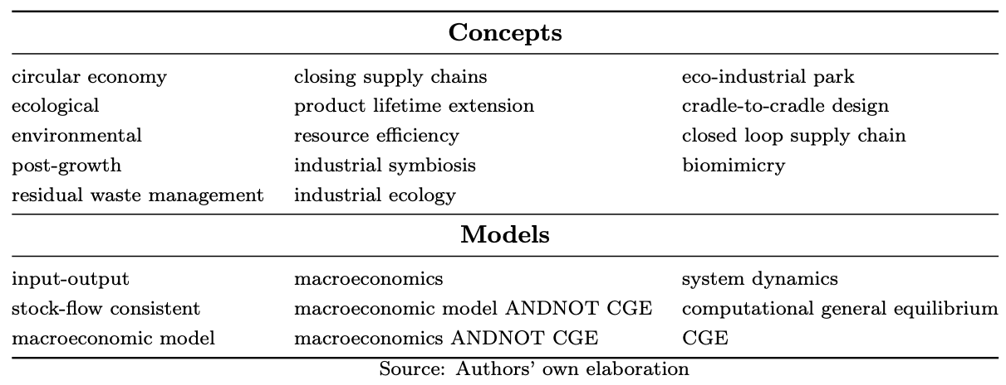

Table 2. Balance-sheet matrix in period 20 (current prices, Area 1 currency)

|  | Area 1 | | | | |  | Area 2 | | | | |  |
| --- | --- | --- | --- | --- | --- | --- | --- | --- | --- | --- | --- | --- |
|  | H | F | G | B | CB | *xr* | H | F | G | B | CB | Tot |
| Money | 74.31 |  |  |  | -74.31 | 1 | 74.31 |  |  |  | -74.31 | 0.00 |
| Advances |  |  |  | 0.00 | 0.00 | 1 |  |  |  | 0.00 | 0.00 | 0.00 |
| Deposits | 444.09 |  |  | -444.09 |  | 1 | 444.09 |  |  | -444.09 |  | 0.00 |
| Loans | -14.66 | -95.86 |  | 110.53 |  | 1 | -14.66 | -95.86 |  | 110.53 |  | 0.00 |
| Area 1 bills | 27.86 |  | -449.66 | 333.56 | 74.31 | 1 | 13.93 |  |  |  |  | 0.00 |
| Area 2 bills | 13.93 |  |  |  | 0.00 | 1 | 27.86 |  | -449.66 | 333.56 | 74.31 | 0.00 |
| Area 1 shares | 11.14 | -11.70 |  |  |  | 1 | 0.56 |  |  |  |  | 0.00 |
| Area 2 shares | 0.56 |  |  |  |  | 1 | 11.14 | -11.70 |  |  |  | 0.00 |
| Capital stock |  | 107.56 |  |  |  | 1 |  | 107.56 |  |  |  | 215.13 |
| Net financial wealth | -557.22 |  | 449.66 |  |  | 1 | -557.22 |  | 449.66 |  |  | -215.13 |
| Total | 0.00 | 0.00 | 0.00 | 0.00 | 0.00 |  | 0.00 | 0.00 | 0.00 | 0.00 | 0.00 | 0.00 |

Table 3. Transactions-flow matrix in period 20 (current prices, Area 1 currency)

|  | Area 1 | | | | | |  | Area 2 | | | | | |  |
| --- | --- | --- | --- | --- | --- | --- | --- | --- | --- | --- | --- | --- | --- | --- |
|  | H | F (y) | F (k) | G | B | CB | *xr* | H | F (y) | F (k) | G | B | CB | Tot |
| Consumption | -745.07 | 745.07 |  |  |  |  | 1 | -745.07 | 745.07 |  |  |  |  | 0.00 |
| Investment |  | 8.04 | -8.04 |  |  |  | 1 |  | 8.04 | -8.04 |  |  |  | 0.00 |
| Government spending |  | 183.87 |  | -183.87 |  |  | 1 |  | 183.87 |  | -183.87 |  |  | 0.00 |
| Export of Area 1 |  | 28.78 |  |  |  |  | 1 |  | -28.78 |  |  |  |  | 0.00 |
| Import of Area 1 |  | -28.78 |  |  |  |  | 1 |  | 28.78 |  |  |  |  | 0.00 |
| $[$ Value added $]$ |  | $[$ 922.09 $]$ |  |  |  |  | 1 |  | $[$ 922.09 $]$ |  |  |  |  | 0.00 |
| Wage bill | 432.49 | -432.49 |  |  |  |  | 1 | 432.49 | -432.49 |  |  |  |  | 0.00 |
| Corporate profit | 480.64 | -480.64 | 0.00 |  |  |  | 1 | 480.64 | -480.64 | 0.00 |  |  |  | 0.00 |
| Amortization |  | -5.24 | 5.24 |  |  |  | 1 |  | -5.24 | 5.24 |  |  |  | 0.00 |
| Bank profit | 8.83 |  |  |  | -8.83 |  | 1 | 8.83 |  |  |  | -8.83 |  | 0.00 |
| CB profit |  |  |  | 2.96 |  | -2.96 | 1 |  |  |  | 2.96 |  | -2.96 | 0.00 |
| Income tax revenue | -184.73 |  |  | 184.73 |  |  | 1 | -184.73 |  |  | 184.73 |  |  | 0.00 |
| VAT revenue |  | -14.61 |  | 14.61 |  |  | 1 |  | -14.61 |  | 14.61 |  |  | 0.00 |
| Tariffs revenue |  | -0.28 |  | 0.28 |  |  | 1 |  | -0.28 |  | 0.28 |  |  | 0.00 |
| Interests on deposits | 8.83 |  |  |  | -8.83 |  | 1 | 8.83 |  |  |  | -8.83 |  | 0.00 |
| Interests on loans | -0.55 | -3.72 |  |  | 4.27 |  | 1 | -0.55 | -3.72 |  |  | 4.27 |  | 0.00 |
| Interests on Area 1 bills | 1.11 |  |  | -18.01 | 13.39 | 2.96 | 1 | 0.56 |  |  |  |  |  | 0.00 |
| Interests on Area 2 bills | 0.56 |  |  |  |  | 0.00 | 1 | 1.11 |  |  | -18.01 | 13.39 | 2.96 | 0.00 |
| Change in money stock | -0.29 |  |  |  |  | 0.29 | 1 | -0.29 |  |  |  |  | 0.29 | 0.00 |
| Change in advances |  |  |  |  | 0.00 | 0.00 | 1 |  |  |  |  | 0.00 | 0.00 | 0.00 |
| Change in deposits | -2.52 |  |  |  | 2.52 |  | 1 | -2.52 |  |  |  | 2.52 |  | 0.00 |
| Change in loans | 0.90 |  | 2.76 |  | -3.66 |  | 1 |  |  | 2.76 |  | -3.66 |  | 0.00 |
| Change in Area 1 bills | -0.11 |  |  | -0.70 | 1.14 | -0.29 | 1 | -0.05 |  |  |  |  |  | 0.00 |
| Change in Area 2 bills | -0.05 |  |  |  |  | 0.00 | 1 | -0.11 |  |  | -0.70 | 1.14 | -0.29 | 0.00 |
| Change in Area 1 shares | -0.04 |  | 0.04 |  |  |  | 1 |  |  |  |  |  |  | 0.00 |
| Change in Area 2 shares |  |  |  |  |  |  | 1 | -0.04 |  | 0.04 |  |  |  | 0.00 |
| Revaluation effects | 0.00 | 0.00 | 0.00 | 0.00 | 0.00 | 0.00 | 1 | 0.00 | 0.00 | 0.00 | 0.00 | 0.00 | 0.00 | 0.00 |
| Total | 0.00 | 0.00 | 0.00 | 0.00 | 0.00 | 0.00 |  | 0.00 | 0.00 | 0.00 | 0.00 | 0.00 | 0.00 | 0.00 |

Table 4. Multi-area input-output matrix in period 20 (current prices, Area 1 currency)

|  | Area 1 demand for inputs | | | | |  | Area 2 demand for inputs | | | | |  |  |  |
| --- | --- | --- | --- | --- | --- | --- | --- | --- | --- | --- | --- | --- | --- | --- |
|  | M | A | S | W | R |  | M | A | S | W | R | Final dem. | Output |  |
| Area 1 production |  |  |  |  |  |  |  |  |  |  |  |  |  |  |
| Manufacturing | 67.01 | 66.89 | 67.13 | 26.13 | 0.00 |  | 5.58 | 5.57 | 5.59 | 2.18 | 0.00 | 312.33 | 558.43 |  |
| Agriculture | 67.01 | 66.89 | 67.13 | 26.13 | 0.00 |  | 5.58 | 5.57 | 5.59 | 2.18 | 0.00 | 311.35 | 557.45 |  |
| Services | 67.01 | 66.89 | 67.13 | 26.13 | 0.00 |  | 5.58 | 5.57 | 5.59 | 2.18 | 0.00 | 313.31 | 559.41 |  |
| Waste manag. | 67.00 | 66.89 | 67.12 | 0.00 | 0.00 |  | 5.58 | 5.57 | 5.59 | 0.00 | 0.00 | 0.00 | 217.76 |  |
| Recycling | 0.00 | 0.00 | 0.00 | 0.00 | 0.00 |  | 0.00 | 0.00 | 0.00 | 0.00 | 0.00 | 0.00 | 0.00 |  |
| Area 2 production |  |  |  |  |  |  |  |  |  |  |  |  |  |  |
| Manufacturing | 5.58 | 5.57 | 5.59 | 2.18 | 0.00 |  | 67.01 | 66.89 | 67.13 | 26.13 | 0.00 | 312.33 | 558.43 |  |
| Agriculture | 5.58 | 5.57 | 5.59 | 2.18 | 0.00 |  | 67.01 | 66.89 | 67.13 | 26.13 | 0.00 | 311.35 | 557.45 |  |
| Services | 5.58 | 5.57 | 5.59 | 2.18 | 0.00 |  | 67.01 | 66.89 | 67.13 | 26.13 | 0.00 | 313.31 | 559.41 |  |
| Waste manag. | 5.58 | 5.57 | 5.59 | 0.00 | 0.00 |  | 67.00 | 66.89 | 67.12 | 0.00 | 0.00 | 0.00 | 217.76 |  |
| Recycling | 0.00 | 0.00 | 0.00 | 0.00 | 0.00 |  | 0.00 | 0.00 | 0.00 | 0.00 | 0.00 | 0.00 | 0.00 |  |
| Value added |  |  |  |  |  |  |  |  |  |  |  |  |  |  |
| ~ Compensation of employees | 128.65 | 128.41 | 128.89 | 46.55 | 0.00 |  | 128.65 | 128.41 | 128.89 | 46.55 | 0.00 |  |  |  |
| ~ G.O. surplus and mixed incomes | 139.41 | 139.18 | 139.64 | 86.27 | 0.00 |  | 139.41 | 139.18 | 139.64 | 86.27 | 0.00 |  |  |  |
| Taxes on production | 0.00 | 0.00 | 0.00 | 0.00 | 0.00 |  | 0.00 | 0.00 | 0.00 | 0.00 | 0.00 |  |  |  |
| Output | 558.43 | 557.45 | 559.41 | 217.76 | 0.00 |  | 558.43 | 557.45 | 559.41 | 217.76 | 0.00 |  |  |  |

Table 5. Area-specific physical flow matrix in period 20 (matter = Gt, energy = EJ)

|  |  |  |  |  |  |  |  |
| --- | --- | --- | --- | --- | --- | --- | --- |
|  | Matter | | |  | Energy | | |
|  | Area 1 | Area 2 | Global |  | Area 1 | Area 2 | Global |
| Inputs |  |  |  |  |  |  |  |
| Extracted matter | 1449.58 | 1449.58 | 2899.15 |  |  |  |  |
| Recycled socio-economic stock | 22.61 | 22.61 | 45.23 |  |  |  |  |
| Renewable energy |  |  |  |  | 1505.18 | 1505.18 | 3010.35 |
| Non-renewable energy | 19.86 | 19.86 | 39.73 |  | 9246.08 | 9246.08 | 18492.15 |
| Oxygen | 53.04 | 53.04 | 106.07 |  |  |  |  |
| Outputs |  |  |  |  |  |  |  |
| Industrial CO2 emissions | -72.90 | -72.90 | -145.80 |  |  |  |  |
| Discarded socio-economic stock | -113.07 | -113.07 | -226.15 |  |  |  |  |
| Dissipated energy |  |  |  |  | -10751.25 | -10751.25 | -21502.5 |
| Δ in socio-economic stock | 1359.12 | 1359.12 | 2718.23 |  |  |  |  |
| Difference | 0 | 0 | 0 |  | 0 | 0 | 0 |

Table 6. Global physical stock-flow matrix in period 20 (matter = Gt, energy = EJ)

|  |  |  |  |  |
| --- | --- | --- | --- | --- |
|  | Material reserves | Energy reserves | CO2 concentration | Socio-economic stock |
| Initial stock | 9451272.53 | -201005.29 | 2100.77 | 40826.5 |
| Resources converted into reserves | 193156.73 | 1536.04 |  |  |
| CO2 emissions |  |  | 145.80 |  |
| Production of material goods |  |  |  | 2944.38 |
| Extraction/us of matter/energy | -2899.15 | -18492.15 |  |  |
| Destruction of socio-economic stock |  |  |  | -226.15 |
| Final stock | 9641530.11 | -217961.4 | 2246.57 | 43544.73 |
| Difference | 0 | 0 | 0 | 0 |

Figure 1. Flow Chart Methodology

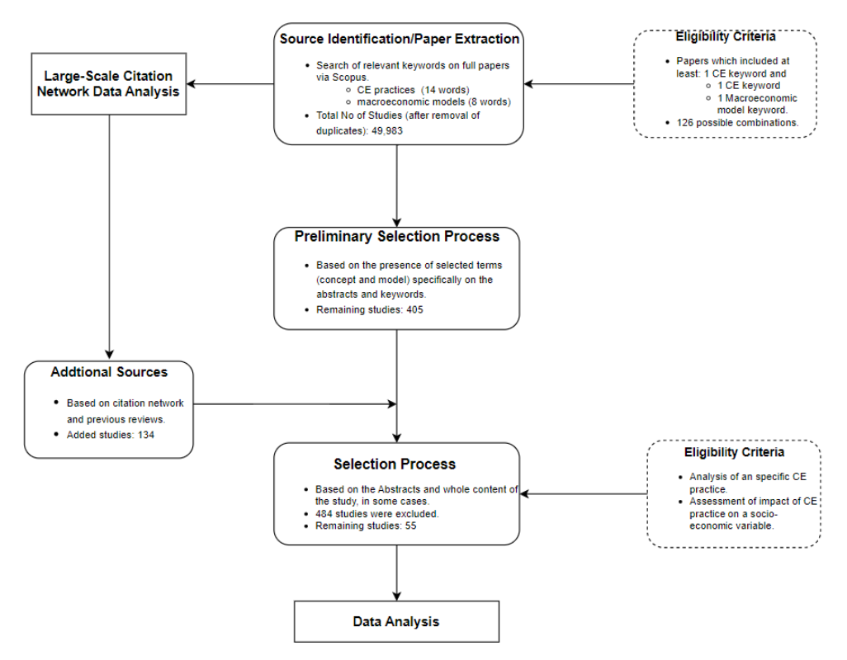

Figure 2. CE Concepts as a Share of Number of Articles by Model

Figure 3. Citation Network Visualization



Figure 4. Time Evolution of Number of Articles by Model and Concept, 1972-2022



Figure 5. Sankey diagram of cross-sector transactions and changes in stocks in $t=10$

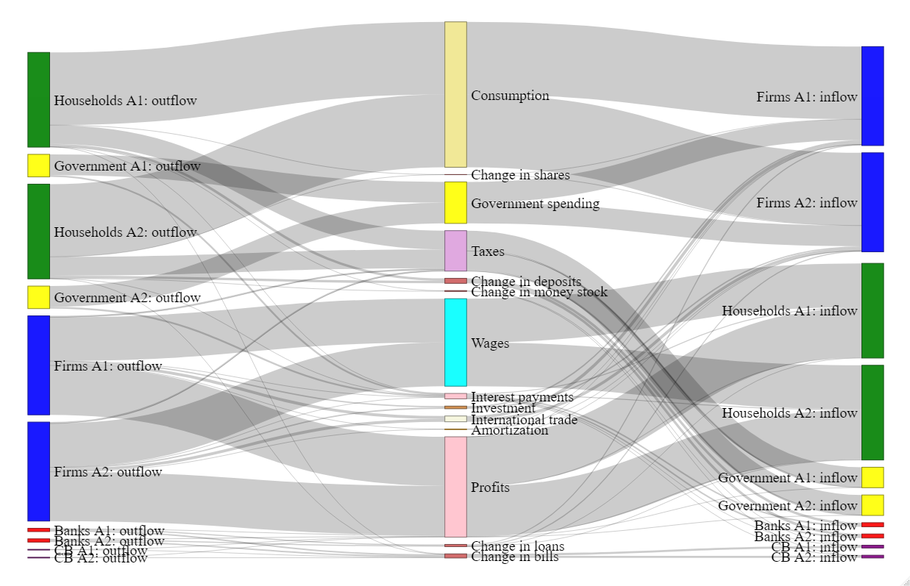

Figure 6. Sankey diagram of cross-industry interdependencies in $t=10$

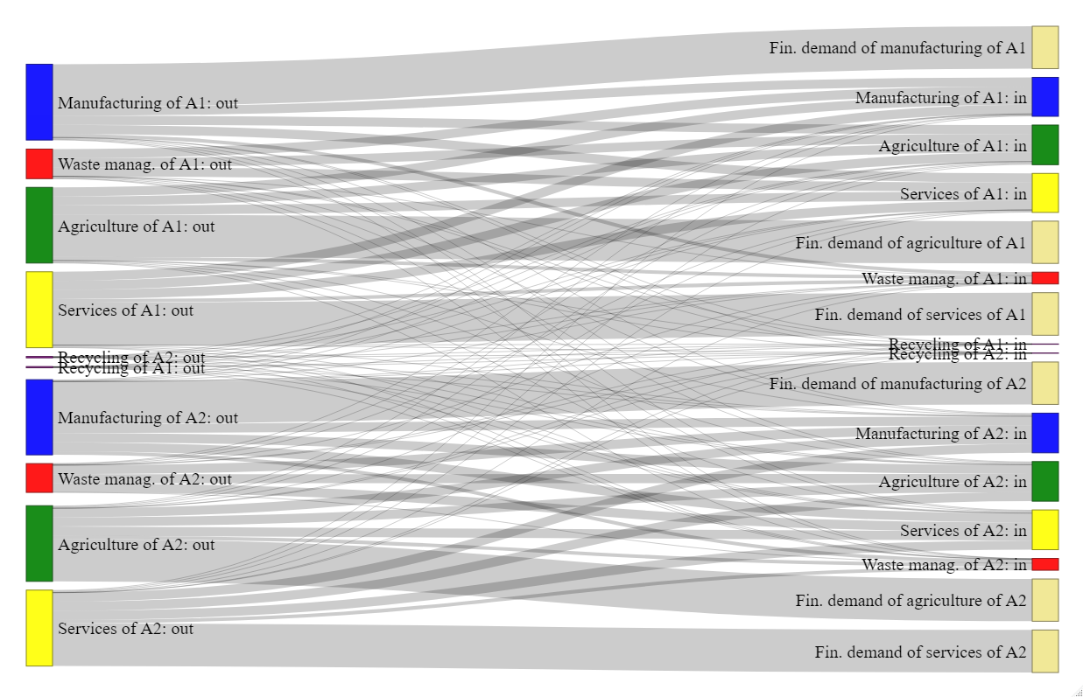

Figure 7. Adjustment of selected economic variables to their steady-state values under the baseline scenario

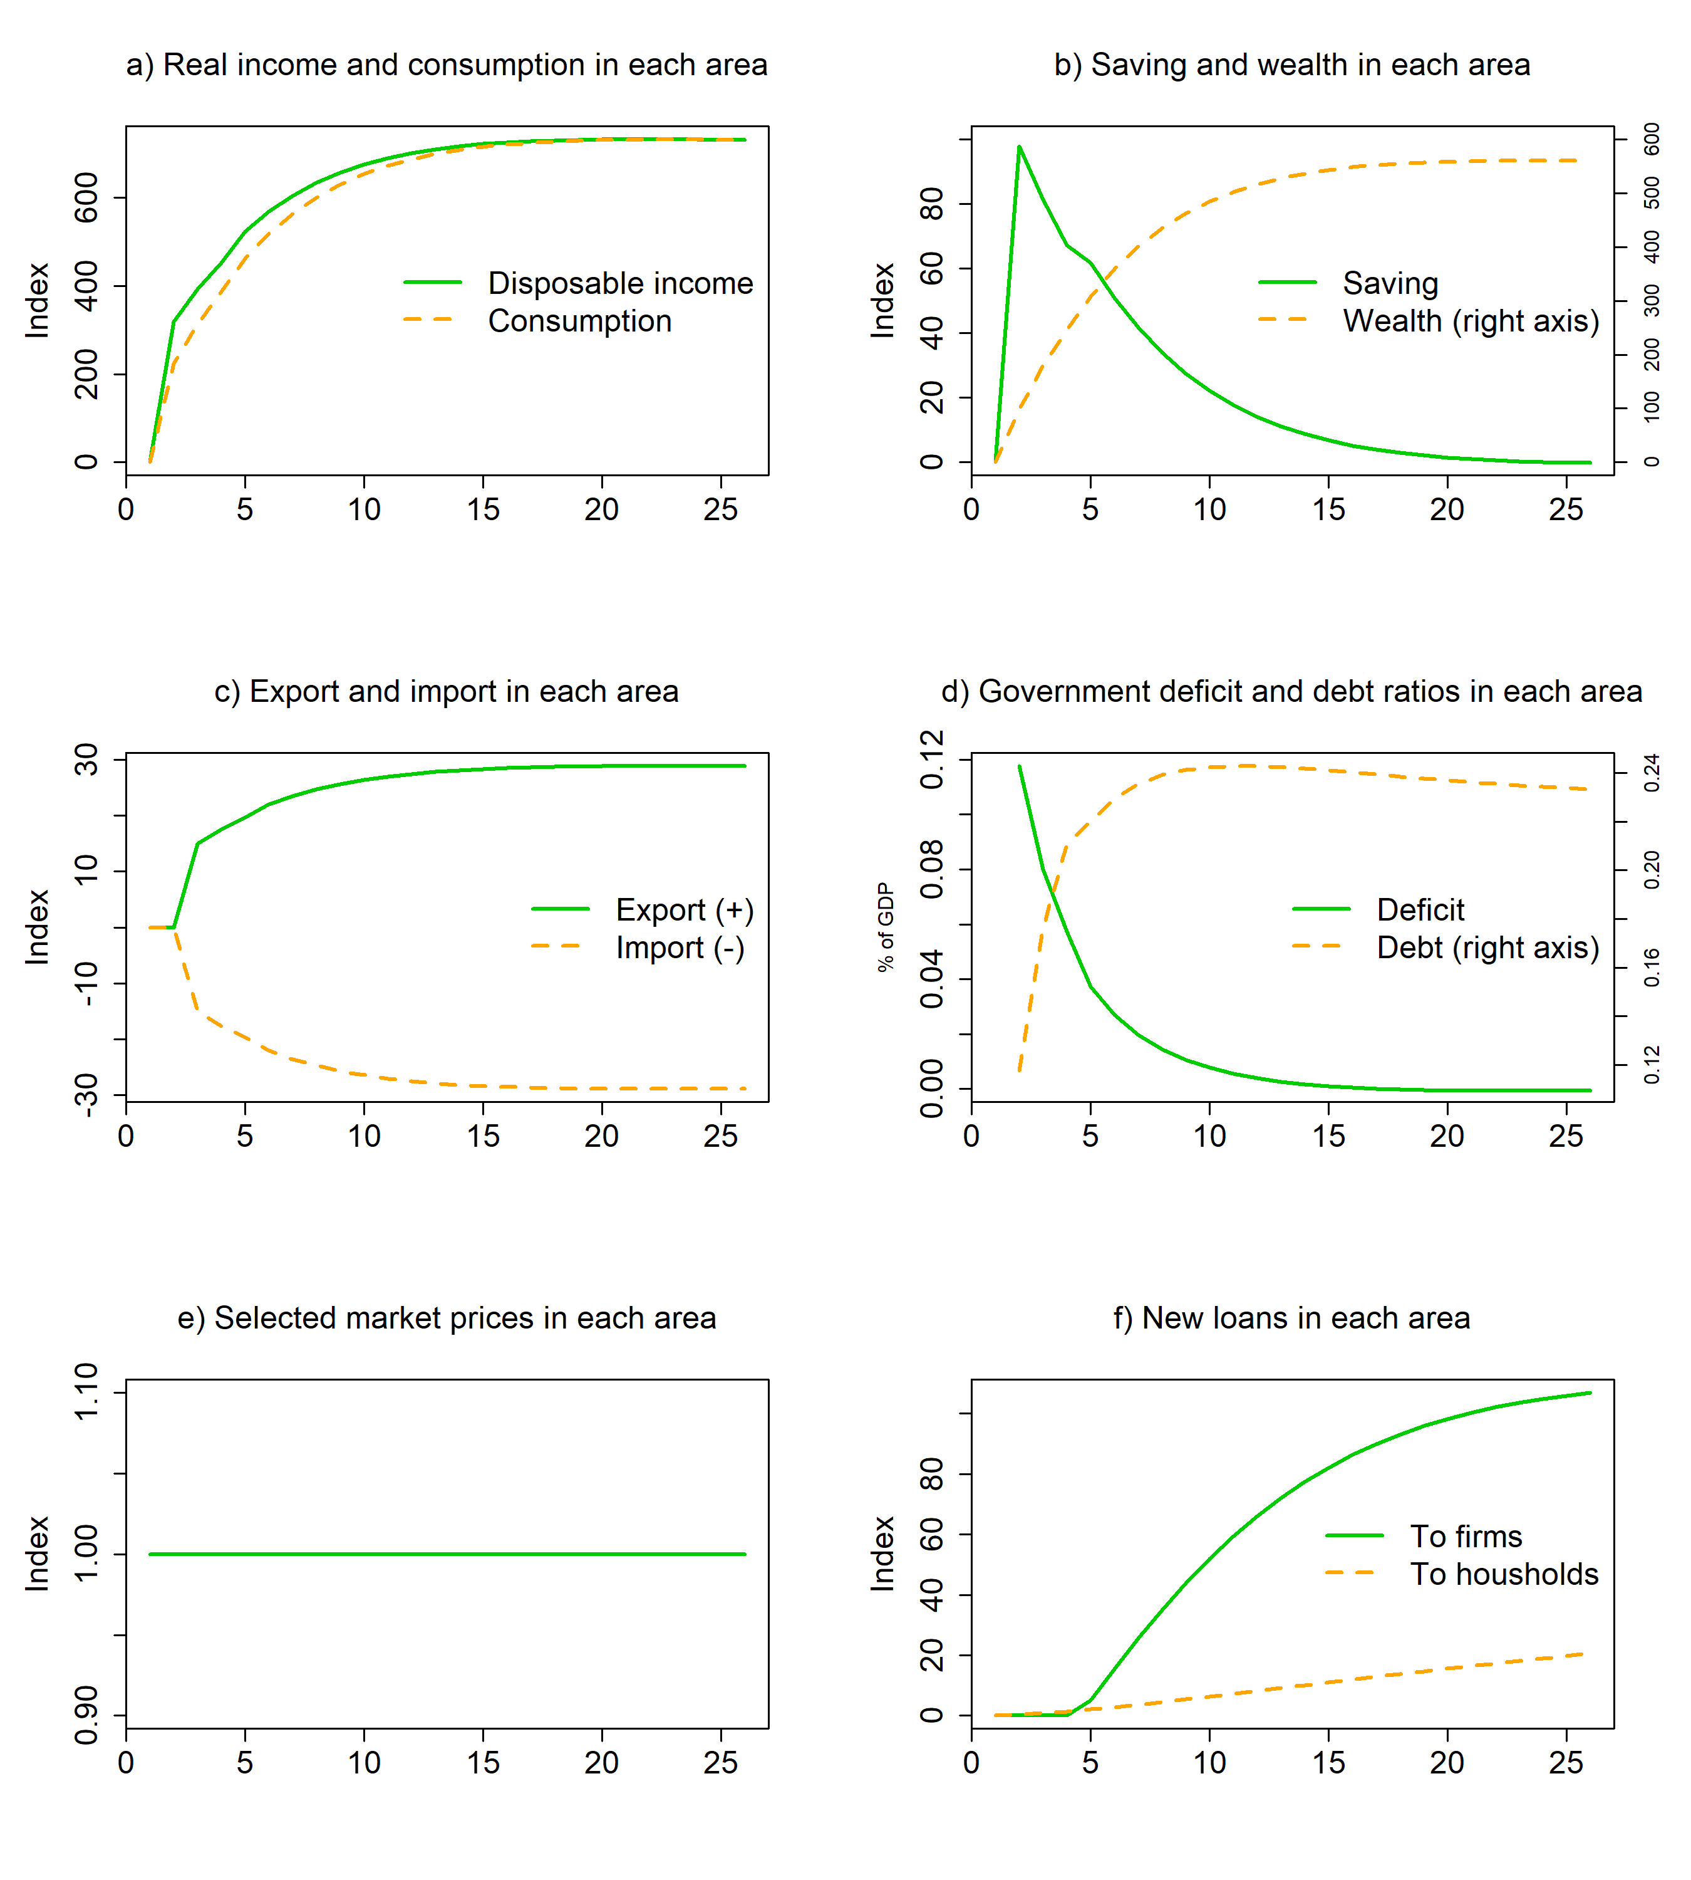

Figure 8. Adjustment of selected economic and ecological variables to their steady-state values under the baseline scenario

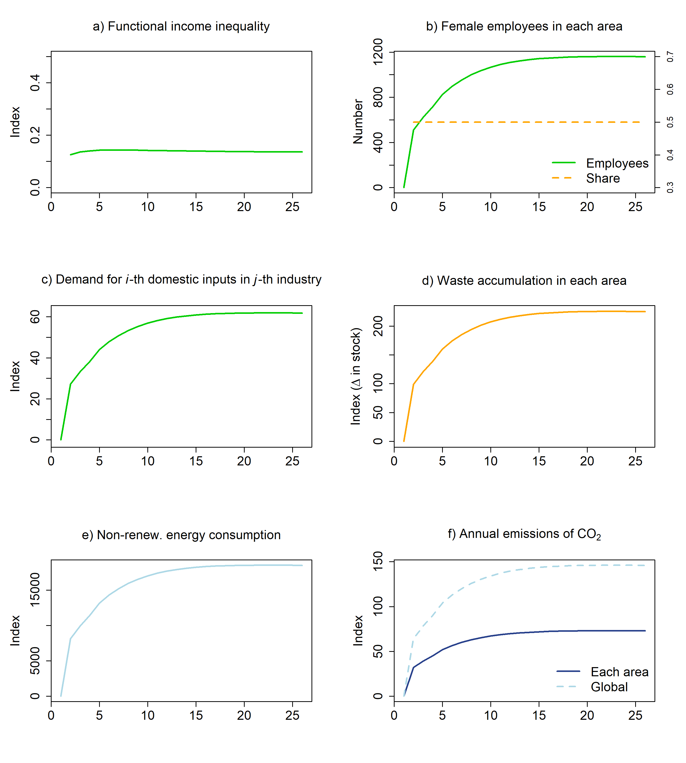

Figure 9. Dynamics of selected economic variables following a CE innovation in a closed economy

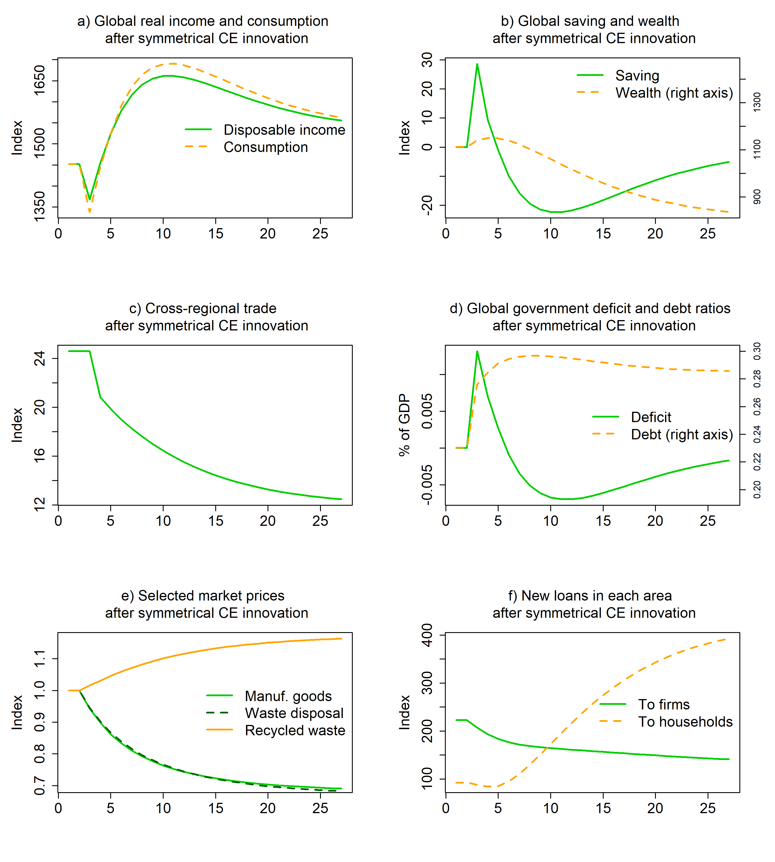

Figure 10. Dynamics of selected economic and ecological variables following a CE innovation in a closed economy

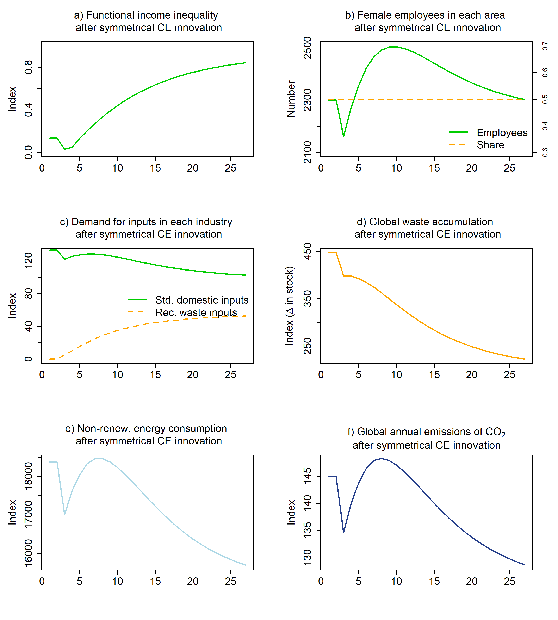

Figure 11. Dynamics of selected economic variables following a CE innovation in Area 1 under a fixed exchange rate regime

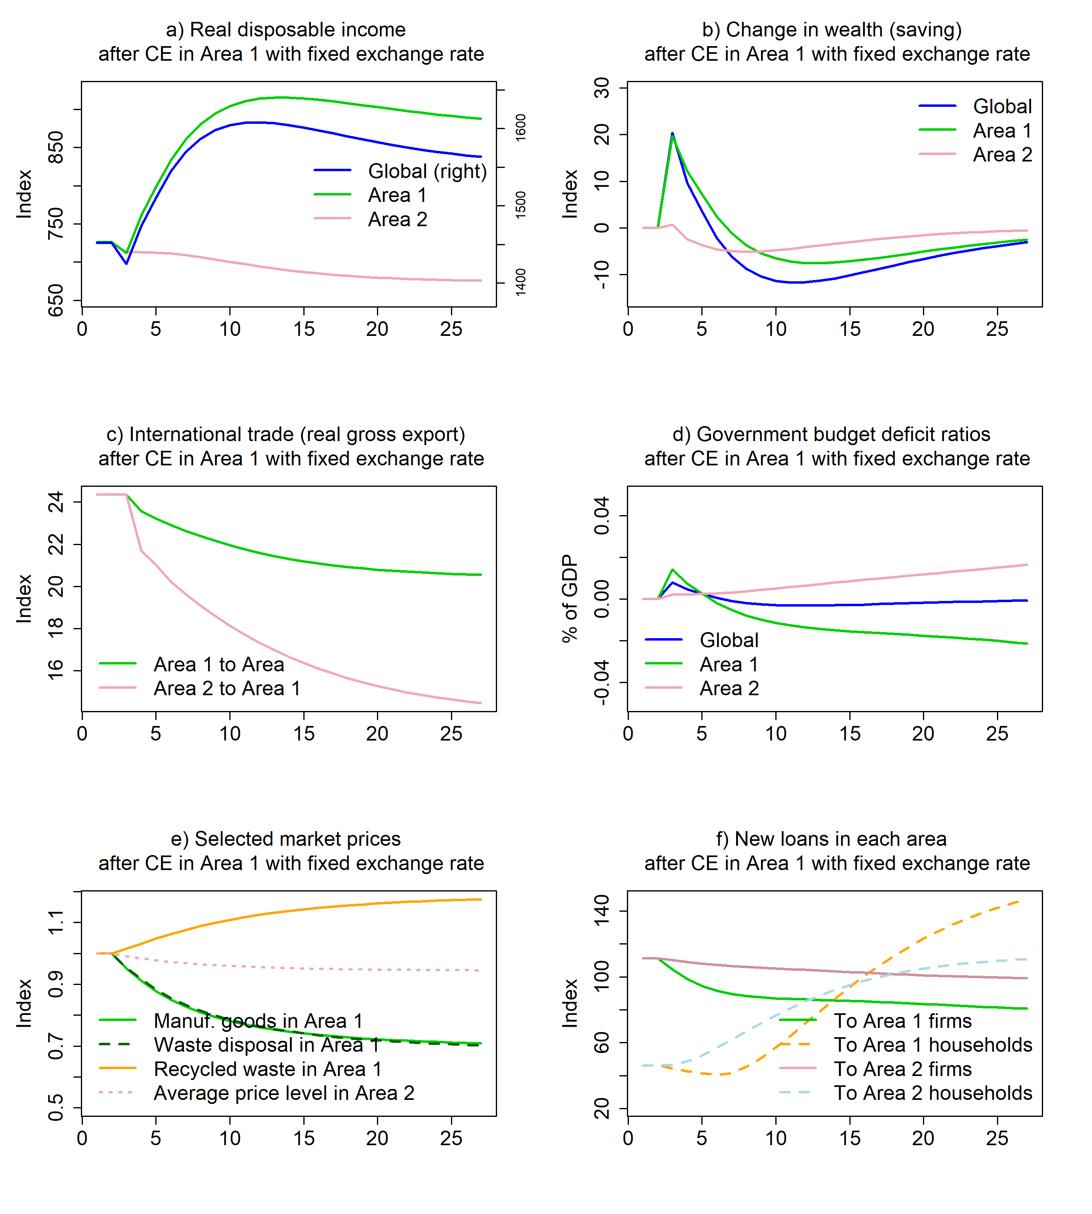

Figure 12. Dynamics of selected economic and ecological variables following a CE innovation in Area 1 under a fixed exchange rate regime

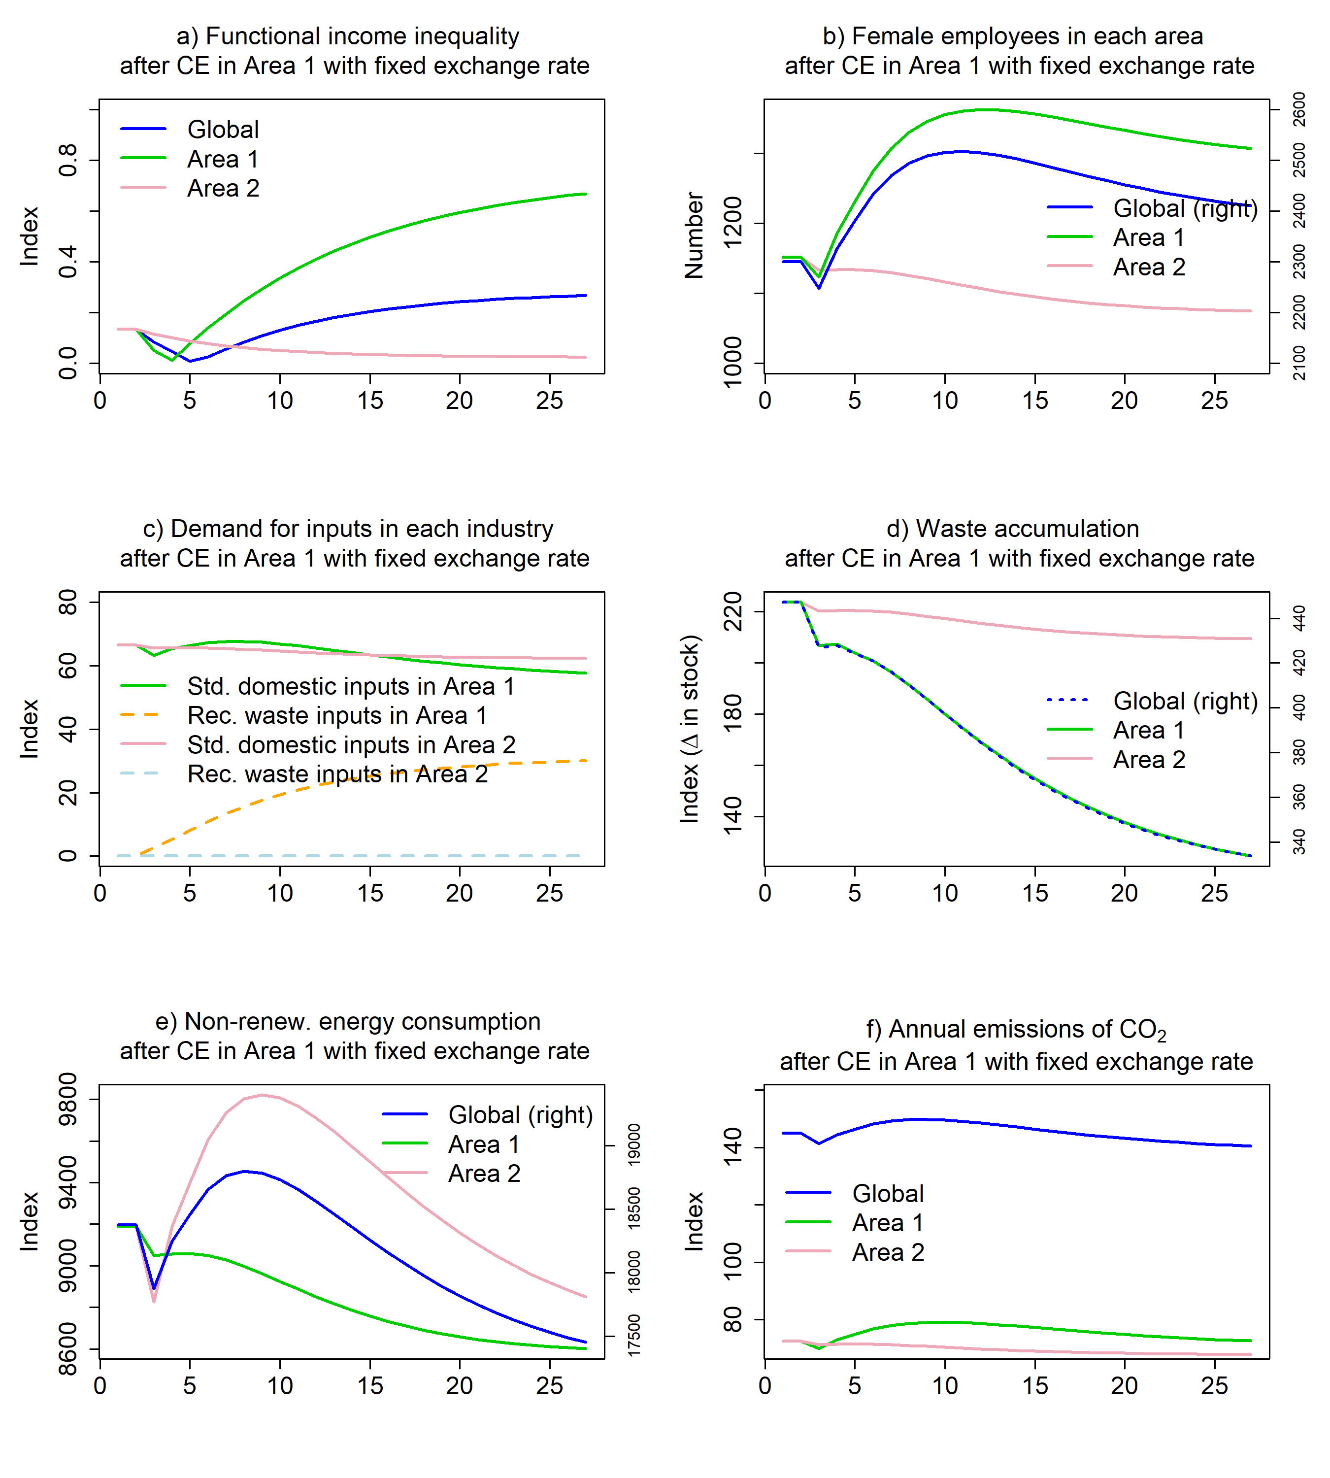

Figure 13. Dynamics of selected economic variables following a CE innovation in Area 1 under a semi-floating exchange rate regime

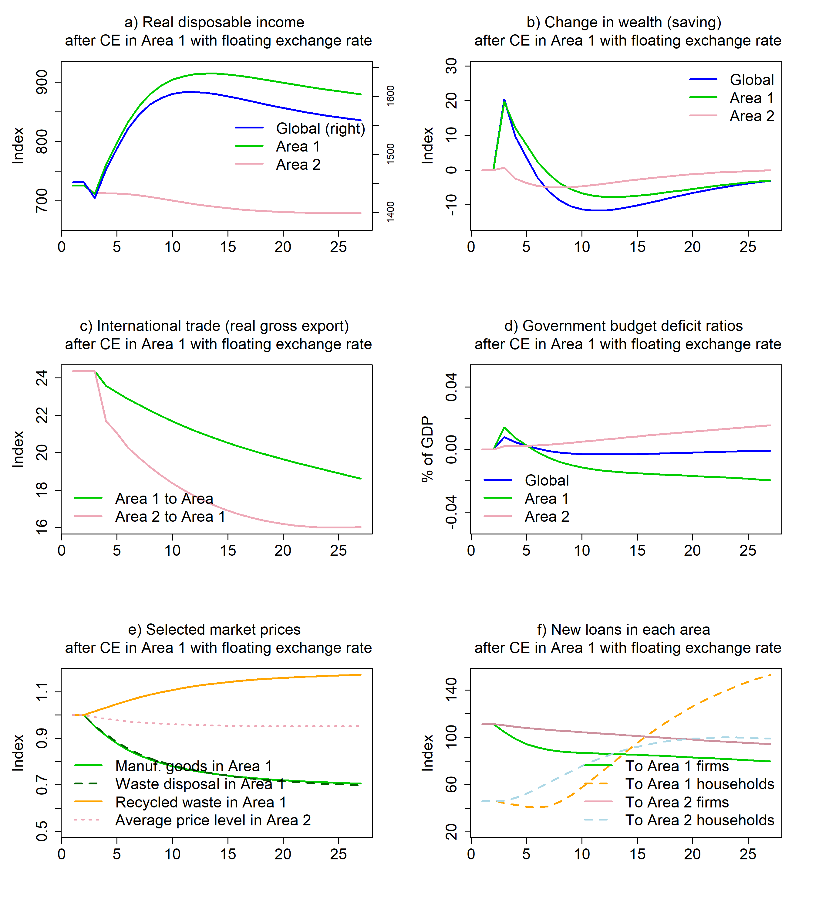

Figure 14. Dynamics of selected economic and ecological variables following a CE innovation in Area 1 under a semi-floating exchange rate regime

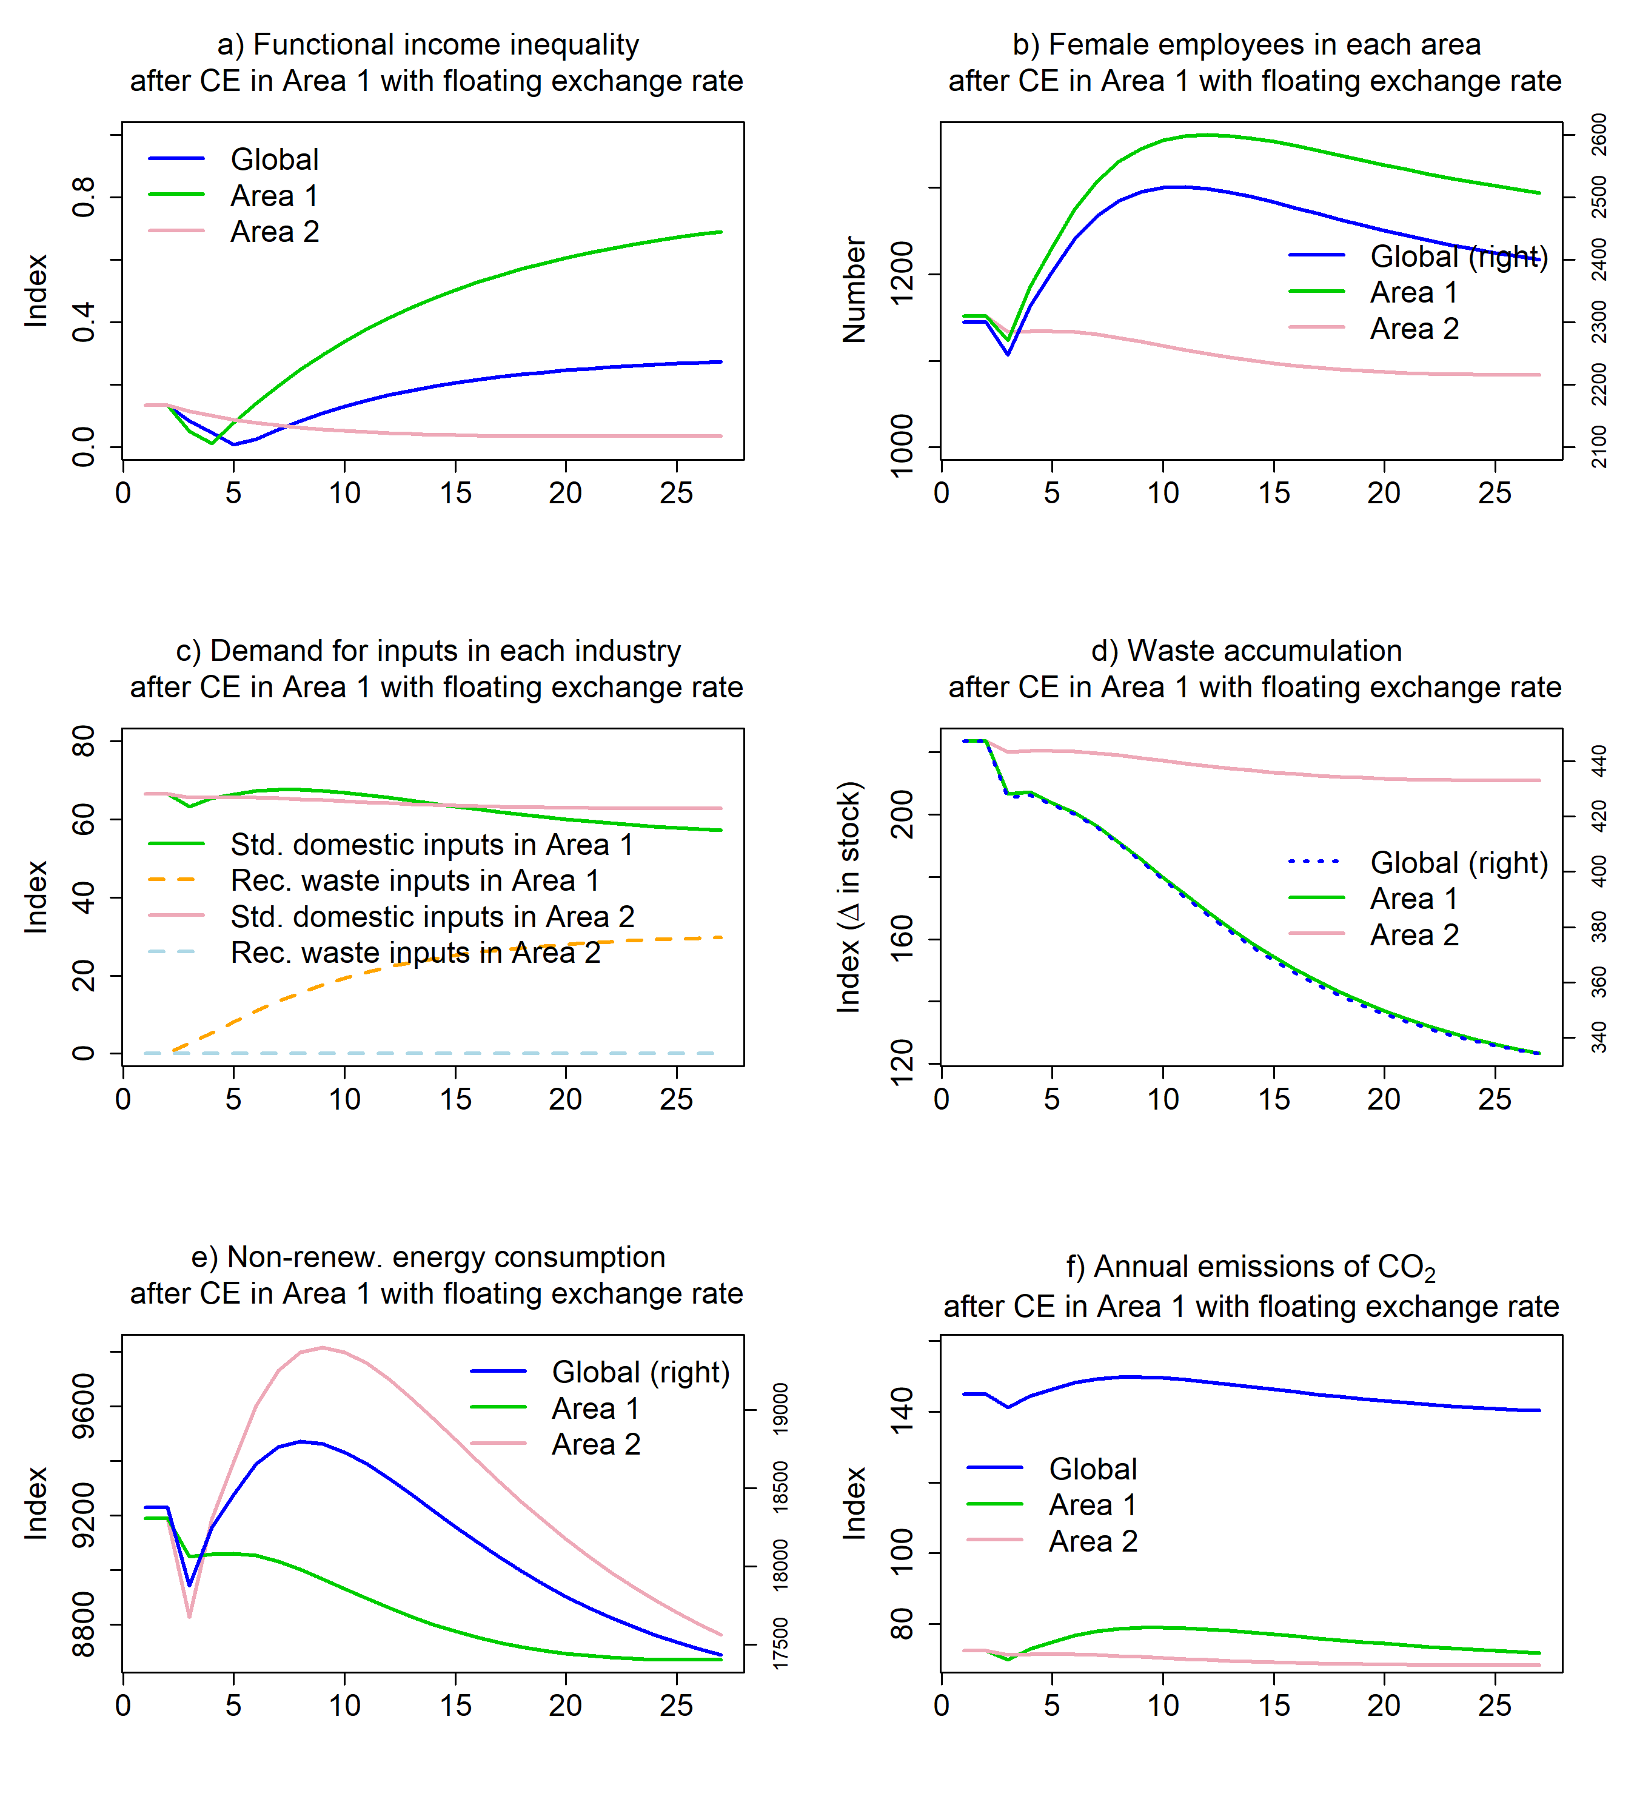



1. Throughout the remainder of this document, we will employ the term ‘industry’ to refer to distinct branches of production (such as agriculture, manufacturing, services, etc.), in contrast to the term ‘sector’, which will be utilised to delineate divisions within the economy/society (including households, firms, banks, government, etc.).
2. Although some specific measures could involve substitution of materials, which lead to a reduction of the technical coefficient in one element and an increase in another.
3. Rebound effects can be defined as when an initial increase in efficiency reduces demand which is (partially) offset in the longer run, as reduction in costs and/or increases in real income increases demand.
4. Even though in the baseline scenario it is set to zero.
5. In line with what most central banks (aside from the FED in the US).
6. Assumed to be higher than the mark-up of government bills in the simulations.
7. The socio-economic stock of each economy is here defined as the quantity of durable goods that are available for the society.
8. See Godley and Lavoie (2012) for a description of balance-sheet and transactions-flow matrices in stock-flow consistent models.
9. The reason we consider 10 periods (rather than 20) is that this choice allows us to highlight the changes in stocks occurring while the economy is transitioning and adjusting to the new equilibrium position after the initial shock (the so-called ‘traverse’). We will discuss this further in the upcoming paragraphs.
10. The model also enables the tracking of functional distribution of income, immigration, gender segregation in the labour market, and other socially relevant variables. However, we assume that both the female labour force and immigrants are uniformly distributed across industries in the baseline scenario.
11. Purely adaptive price expectations are assumed in the baseline scenario, so that: $E\left(p_{A}^{z}\right)=p_{A,-1}^{z}$. Besides, the impact of the so-called ‘inflation tax’ on real disposable income is ignored.
12. Exchange rates are quoted indirectly. As a result, $xr^{z}$ is the price of one unit of domestic currency expressed in foreign currency, whereas, for the ‘home’ area, $xr^{f}$ is the price of one unit of foreign currency expressed in domestic currency.
13. For each area, the vector of export shares mirror the vector of import shares of the other area.
14. Notice that the term ${\left(\text{I}-\text{A}\right)}^{-1}$ is a matrix too. It is named the *Leontief inverse* and shows the multipliers, that is, the successive changes in production processes triggered by an initial change in final demands. As is well known, the Leontief inverse matrix can be expressed as a sum of power series (Waugh 1950[@fvw:1950]), that is: .
15. As we are explaining in subsection A.8, $p_{I}^{z}$ is the average price of investment goods and $p_{G}^{z}$ is the average price of goods purchased by the government sector.
16. Notice that $k^{*}$ cannot be expressed in physical units. It is calculated by dividing the nominal stock of capital by the average price of investment goods. See subsection 2.8.
17. However, it is assumed that $g_{g}^{z}=0$ in the baseline scenario.
18. Note that $⊙$ and $⊘$ are the Hadamard multiplication and division, respectively, also called element-wise multiplication and division of matrices.
19. Note that $λ$ s are defined in such a way that: *a*) horizontal constraints on coefficients of rates of interest/return for each financial asset are met; *b*) vertical constraints for cross-asset coefficients of rates of interest/return are met; and *c*) the sum of autonomous shares of assets to total wealth (additional vertical constraints) is lower than unity, because households can hold cash and bank deposits in addition to government bills and corporate equity (see Godley and Lavoie 2007, sections 5.6.2 and 5.6.3). These constraints must be verified at the global level.
20. We refer again to subsection 2.2.
21. It follows that actual marks-ups fall below normal mark-ups as long as $p_{j}^{z}<p_{j}^{z*}$, and they exceed them as long as , .
22. For the sake of simplicity, we assume away bank reserves.
23. In this scenario, the domestic central bank should be purchasing all the unsubscribed foreign bills to maintain exchange rate stability.
24. For a thorough discussion on the definition of CE, see Bimpizas-Pinis et al. (2021).
25. As CE innovation seems to imply some degree of input substitutability, one might notice that *smooth substitutability*, within the *same production function*, is one of the key assumptions of neoclassical general equilibrium models. However, input substitution is only possible here because of a *change in the techniques of production*.
26. Notice that: .